**MINOR PROJECT REPORT ON**

Career Recommendation System

*Submitted in partial fulfilment of the requirements for the award of the degree of*

**BACHELOR OF COMPUTER APPLICATIONS**



**Batch: 2021 - 24**

***Under the Guidance of Submitted By***

Dr. Ruchi Sawhney Dibya Bharat Khatua

(Assistant Professor) 00928402021

**Bosco Technical Training Society**

**Don Bosco Technical School, Okhla Road, New Delhi-110025**

**9643868820, 8527787221, 011-41033889**

**Affiliated to**



**Guru Gobind Singh Indraprastha University**

### Sector - 16C, Dwarka, New Delhi - 110078 (India)

### Phone: +91-11-25302170, Fax: +91-11- 25302111

### E-Mail Id: ggsipu.pr@rediffmail.com, pro@ipu.ac.in

## **Acknowledgement**

The note starts with thanks to Almighty who actually created this piece of work and helped us when things were not easy for us.

I am very grateful and indebted to my Faculty/Guide Dr. Ruchi Sawhney (Assistant Professor) who immensely helped and rendered her valuable advice, precious time, knowledge and relevant information regarding the collection of material. She has been a major source of inspiration throughout the project as she not only guided me throughout this Project Report “Career Recommendation System” but also encouraged me to solve problems that arose during this report.

Her guidance and suggestions about this Project report have really enlightened me. It has been a great help to support to have him around.

And finally, I would like to mention appreciation to our parents and friends who have been instrumental throughout this period by providing unrelenting encouragement.

Signature

Dibya Bharat Khatua

00928402021

**SELF-CERTIFICATE**

This is to certify that the dissertation/project report entitled “Career Recommendation System” done by me is an authentic work carried out for the partial fulfilment of the requirements for the award of the degree of Bachelor of Computer Applications under the guidance of Dr. Ruchi Sawhney (Assistant Professor). The matter embodied in this project work has not been submitted earlier for award of any degree or diploma to the best of my knowledge and belief.

Signature of the student

Dibya Bharat Khatua

00928402021

**CERTIFICATE**

This is to certify that this project entitled **“Career Recommendation System”** submitted in partial fulfilment of the degree of Bachelor of Computer Applications to **Dr. Ruchi Sawhney** (Assistant Professor) through Guru Gobind Singh Indraprastha University, Delhi done by **Mr. Dibya Bharat Khatua , Roll No. 00928402021** is an authentic work carried out by him at Bosco Technical Training Society, Don Bosco Technical School under my guidance. The matter embodied in this project work has not been submitted earlier for award of any degree to the best of my knowledge and belief.

Signature of the student Signature of the Guide

SYNOPSIS

# **1. Problem Statement**

# 

* 1. **Problem:**

The "Career Recommendation System" project addresses a pressing issue in the educational landscape, primarily concerning students transitioning from their 10th-grade examinations. At this critical juncture, students often find themselves at a crossroads, faced with the formidable task of choosing academic courses or streams that will significantly shape their future careers. However, the educational system currently lacks a structured and comprehensive decision-making framework to guide students through this crucial phase of their academic journey.

In particular, students grapple with several challenges:

* **Lack of Systematic Guidance:** The absence of a systematic guidance system leaves many students in the dark, unsure of which path to follow. Without clear direction, they may make ill-informed decisions that can impact their career prospects for years to come.
* **Balancing Performance and Aspirations:** Striking the right balance between their academic performance, personal interests, and inherent strengths is a complex and often bewildering task. Students must align their educational choices with their career aspirations, a process that is far from straightforward.

As a result, many students are left navigating this critical decision-making process with minimal support or personalized advice. This lack of guidance can have profound consequences on their educational and career trajectories, potentially leading to mismatches between their chosen paths and their true potential.

* 1. **Background:**

The existing educational framework has long grappled with the challenge of equipping students with the tools and knowledge necessary to make informed career choices. Traditionally, students have relied on a mix of limited resources, including career counsellors and educational advisors, which often fall short of providing the personalized guidance needed.

The complexities of aligning academic performance, personal interests, and career goals further exacerbate the problem. The evolving job market demands that students choose their paths with care, as they prepare for careers in fields that are continually changing and diversifying. Consequently, there is a growing need for an innovative solution that addresses these challenges effectively.

* 1. **Relevance:**

The "Career Recommendation System" project is profoundly relevant in the context of today's educational landscape. It directly addresses the critical issue of career decision-making for students, offering a tailored and data-driven approach to support their academic and vocational aspirations. Several key aspects underline the system's relevance:

* **Personalized Recommendations:** By leveraging data on academic performance, personal interests, and strengths, the system provides personalized course and career recommendations. This tailoring ensures that students are directed toward paths that genuinely resonate with their capabilities and aspirations.
* **Subject Weakness Mitigation:** The system goes a step further by diagnosing subject-specific weaknesses. This critical feature empowers students to address these weaknesses and bolster their educational foundations, thereby enhancing their chances of success in their chosen careers.
* **Improved Academic and Career Trajectories:** The project holds the potential to significantly improve students' academic and career trajectories. By offering precise, data-driven recommendations, it helps students make more informed decisions, reducing the likelihood of misaligned choices.

**2. Objectives and Scope**

* 1. **Objectives:**
* Develop a machine learning-driven recommendation system that analyzes students' academic performance, interests, strengths, and career aspirations which provides course, stream, and career recommendations based on content filtering.
* Identify and address subject-specific weaknesses that may hinder students' chosen career paths.
* Implement a questionnaire/test to refine recommendations based on user marks and make further recommendations based on things they can do that they lack awareness of or even provide new things to get interested in for those who have exhausted their option.
* Suggest improvement strategies: For subjects in which students are weak, the system will offer tailored recommendations on strengthening their skills and improving their performance.
  1. **Scope:**
* The project's scope encompasses providing students with informed career recommendations following their 10th-grade examinations.
* Recommendations are personalized through an in-depth analysis of academic data, interests, and subject weaknesses.
* Strategies to enhance proficiency in relevant subjects are offered.

**3. Methodology**

* **Data Collection:** Procure academic performance metrics, interest assessments, and career objectives from student records.
* **Machine Learning Model:** Develop a machine learning model incorporating academic performance, interests, and strengths/weaknesses as feature inputs.
* **Recommendation Generation:** Utilize the model's filtering to generate individualized course or stream recommendations for each student.
* **Improvement Suggestions:** For students with subject-specific weaknesses, provide targeted strategies and resources to enhance their proficiency.
* **Test:** To refine further recommendations based on user marks and on things of they can do that they lack awareness of or even provide new things to get interested in for those who have exhausted their option.
* **User Interface:** Construct a user-friendly interface enabling students to input their information and receive personalized recommendations.

**4. Hardware and Software**

* 1. **Hardware Requirements:**
* RAM: 4 Gb minimum
* Storage: 464 mb minimum
  1. **Software Requirements:**
* Operating system platform- atleast windows 10
* Database management system- SQLite
* Programming languages – Python
* Machine learning libraries and frameworks – sci-kit learn
* Data analysis tools – Pandas, NumPy
* GUI generation libraries: PyQT5
* IDEs: Python IDE, Anaconda Jupyter

**5. Resources and Limitations**

* 1. **Resources:**
* Programming Language libraries suitable for making good UI for computer applications.
* Access to diverse data sources, including academic records and test responses.
* Availability of hardware and software infrastructure.
* Educational resources for suggesting improvement strategies.
  1. **Limitations:**
* Recommendations are contingent on self-assessment, potentially overlooking external factors.
* Recommendation precision hinges on the quality and comprehensiveness of data.
* Ongoing updates to recommendations may be necessitated by evolving career trends.
* User engagement is dependent on the capabilities of the system.

**6. Testing Methodology**

The testing methodology employed for this project is Manual Testing, utilizing White-Box Testing techniques.

**Testing Process:** The testing process encompasses the following steps:

* **Requirements Analysis:** Review and analysis of project documentation to identify testing objectives and requirements.
* **Test Case Developmen**t: Creation of test cases tailored to the identified objectives and requirements.
* **Manual Testing:** Execution of test cases through manual processes.
* **Bug Identification:** The process of identifying and documenting defects or issues encountered during manual testing.

**Completion Criteria:** The testing process is considered complete when all identified test cases have been executed, and no further defects or bugs are found.

**7. Conclusions**

* The "Career Recommendation System" project endeavors to address the pressing issue of pre-secondary career decision-making. The system provides individualized recommendations and guidance by leveraging academic performance, interests, strengths, and career aspirations. The project holds profound significance in the educational domain and stands to significantly enhance students' academic and vocational journeys.

MAIN REPORT

**Index**

1. **Objective and Scope 16**
   1. **Objective 16**
   2. **Scope 16**
   3. **Technical Components 17**
2. **Definition of Problem 29**
   1. **Problem 29**
   2. **Background 30**
   3. **Relevance 31**
3. **System Requirements 32**
   1. **Hardware Requirements 32**
   2. **Software Requirements 32**
4. **System Analysis & Design 33**
   1. **Iterative Model 33**
   2. **Use Case Diagram 35**
5. **System Planning 42**
6. **Methodology 45**
7. **Detailed Life Cycle of the Project 47**
   1. **Entity Relationship Diagram 47**
   2. **Data Flow Diagram 52**
   3. **Input and Output Screen Design 56**
   4. **Process Involved 61**
   5. **Methodology Used in Testing 65**
   6. **Test Report 67**
8. **Coding and Screenshots 83**
9. **Conclusion and Future Scope 190**
10. **References 191**

**List of Figures**

**Figure 1.1 KNN Working 27**

**Figure 2.1 Mindler Survey Graph 30**

**Figure 4.1 Iterative Model 35**

**Figure 4.2 Components of use case diagrams 39**

**Figure 4.3 Use Case Diagram 40**

**Figure 5.1 PERT Chart 44**

**Figure 7.1 Components of ERD 48**

**Figure 7.2 Types of all Components of ERD 49**

**Figure 7.3 Entity Relationship Diagram 51**

**Figure 7.4 Symbols & Components of Data Flow Diagram 54**

**Figure 7.5 Level 0 Data Flow Diagram 55**

**Figure 7.6 Level 1 Data Flow Diagram 55**

**Figure 7.7 Layout of QtDesigner 60**

**Figure 7.8 Activity Diagram 63**

**Figure 7.9 Types of Software Testing 65**

**Figure 7.10 Test Report 1 67**

**Figure 7.11 Test Report 2 68**

**Figure 7.12 Test Report 3 69**

**Figure 7.13 Test Report 4 70**

**Figure 7.14 Test Report 5 71**

**Figure 7.15 Test Report 6 71**

**Figure 7.16 Test Report 7 72**

**Figure 7.17 Test Report 8 73**

**Figure 7.18 Test Report 9 74**

**Figure 7.19 Test Report 10 75**

**Figure 7.20 Test Report 11 76**

**Figure 7.21 Test Report 12 77**

**Figure 7.22 Test Report 13 78**

**Figure 7.23 Test Report 14 79**

**Figure 7.24 Test Report 15 79**

**Figure 7.25 Test Report 16 80**

**Figure 7.26 Test Report 17 81**

**Figure 7.27 Test Report 18 82**

**Figure 7.28 Test Report 19 82**

**Figure 8.1 Output Screenshot 1 89**

**Figure 8.2 Output Screenshot 2 96**

**Figure 8.3 Output Screenshot 3 99**

**Figure 8.4 Output Screenshot 4 118**

**Figure 8.5 Output Screenshot 5 126**

**Figure 8.6 Output Screenshot 6 138**

**Figure 8.7 Output Screenshot 7 155**

**Figure 8.8 Output Screenshot 8 160**

**Figure 8.9 Output Screenshot 9 185**

**Figure 8.10 Output Screenshot 10 189**

**Chapter 1: Objective and Scope**

The career recommendation system is a desktop application project created using the python programming language. This project was created in light of a lack of system to judge and provide students with a straightforward list of jobs based on their scores and interest to not only get view of what they can do with their current scores and skill as well as a view of the weaknesses they need to make up for in order to do what they interested.

**1.1 Objectives:**

* Develop a machine learning-driven recommendation system that analyzes students' academic performance, interests, strengths, and career aspirations which provides course, stream, and career recommendations based on content filtering.
* Identify and address subject-specific weaknesses that may hinder students' chosen career paths.
* Implement a questionnaire/test to refine recommendations based on user marks and make further recommendations based on things they can do that they lack awareness of or even provide new things to get interested in for those who have exhausted their option.
* Suggest improvement strategies: For subjects in which students are weak, the system will offer tailored recommendations on strengthening their skills and improving their performance.

**1.2 Scope:**

* The project's scope encompasses providing students with informed career recommendations following their 10th-grade examinations.
* Recommendations are personalized through an in-depth analysis of academic data, interests, and subject weaknesses.
* Strategies to enhance proficiency in relevant subjects are offered.

The career recommendation system is a desktop application project created using the python programming language. This project was created in light of a lack of system to judge and provide students with a straightforward list of jobs based on their scores and interest to not only get view of what they can do with their current scores and skill as well as a view of the weaknesses they need to make up for in order to do what they interested.

**1.3 Technical Components**

**Python:**

Python is a high-level, general-purpose, and versatile programming language. Python programming language is being used in web development, Machine Learning applications, along with all cutting-edge technology in Software Industry. Python’s Background in Desktop Application Development and Machine Learning comes from its cross-platform nature and various libraries for Example: Pyqt5, Pandas, NumPy, Sci-kit Learn etc.

Features of Python:

1. **Easy to Code:** Python is a high-level programming language. Python is very easy to learn the language as compared to other languages like C, C#, JavaScript, Java, etc. It is very easy to code in the Python language and anybody can learn Python basics in a few hours or days. It is also a developer-friendly language.
2. **Free and open source:** Python language is freely available at the official website and you can download it from the given download link below click on the keyword. Since it is open-source, this means that source code is also available to the public. So, you can download it, use it as well as share it.
3. **GUI support:** Python has various libraries for making Graphical User Interfaces such a Pyqt5, Tkinter or wxPython. PyQt5 is the most popular option for creating graphical apps with Python.
4. **High level language:** Since, Python is a high-level programming language, we don’t need to remember the system architecture nor manage the memory when we use it for programming.
5. **Large Standard Libraries:** Python has a large standard library that provides a rich set of modules and functions so you do not have to write your own code for every single thing. There are many libraries present in Python such as regular expressions, unit-testing, web browsers, etc.
6. **Object-Oriented Programming language:** Python is an Object-Oriented Programming language i.e., it supports Object Oriented language and concepts like classes, object encapsulation, polymorphism etc.
7. **Portable:** Python language is also a portable language. For example, if we have Python code for Windows and if we want to run this code on other platforms such as Linux, Unix, and Mac then we do not need to change it, we can run this code on any platform.

**Pyqt5:**

There are so many options provided by Python to develop GUI application and PyQt5 is one of them. PyQt5 is cross-platform GUI toolkit, it has a set of python bindings for Qt v5. One can develop an interactive desktop application with much ease because of the tools and simplicity provided by this library. A GUI application consists of Front-end and Back-end. PyQt5 has provided a tool called ‘QtDesigner’ to design the front-end by drag and drop method so that development can become faster and one can give more time on back-end stuff.

Due to the nature of Desktop Application development and Pyqt5, Event Driven Programming come into play. It is a programming paradigm where different parts of the application or entities communicate by sending messages to one another through an intermediary. In the context of Gui development and desktop application development this refers to different components reacting to each other through signals and events written out by the programmer. For example, a button being clicked in a Pyqt5 Gui interface is connected to function which would then be executed.

Feature of Pyqt5:

1. **Cross-platform:** Due to the cross-platform nature of Qt, you can develop and deploy application across various platforms without changing the code.
2. **Rich set of widgets:** PyQt5 provides a wide variety of built-in widgets, such as buttons, labels, input fields, sliders, dialogs, tables, and more, enabling the creation of interactive and feature-rich user interfaces.
3. **Signals and slots:** Pyqt5 facilitates communication between objects using a signal and slot mechanism where you connect user interface events (signals) to Python function or methods (slots).
4. **Qt Designer:** PyQt5 includes Qt Designer, a graphical user interface design tool that allows developers to create UIs visually by dragging and dropping widgets onto a form. Generated **.ui** files can be converted to Python code.
5. **Layout management:** In order to organize widgets within a window, Pyqt5 provides layout managers (e.g., QVBoxLayout, QHBoxLayout, QGridLayout), enabling things like automatic arrangement and resizing of UI elements.

**Scikit-Learn:**

Scikit-learn is a powerful open-source library in Python used for machine learning tasks such as classification, regression, clustering, and more. It is built on top of other popular scientific computing libraries, such as NumPy, SciPy, and Matplotlib. It offers a wide range of tools for machine learning and statistical modelling, including various algorithms and utilities for data preprocessing, model selection, evaluation, and data visualization.

In practical terms, scikit-learn serves as a powerful toolbox for tasks such as data preprocessing, model training, and model evaluation. It includes utilities for handling data, implementing feature selection, and assessing model performance through cross-validation and grid search.

Features of Scikit-Learn:

1. **Supervised Learning Algorithms:** Scikit-learn encompasses a wide array of popular supervised learning algorithms such as Linear Regression, Support Vector Machine (SVM), Decision Trees, Random Forests, Gradient Boosting, and more. These algorithms are extensively used for training predictive models where the target variable is known. For instance, Linear Regression is employed in modelling the relationship between dependent and independent variables, while SVMs are efficient classifiers used for both linear and nonlinear data.
2. **Unsupervised Learning Algorithms:** Scikit-learn provides various unsupervised learning algorithms designed for data without labelled responses. It includes clustering algorithms like K-Means, Hierarchical Clustering, and DBSCAN for grouping similar data points. Additionally, it offers factor analysis methods, PCA (Principal Component Analysis), t-SNE (t-distributed Stochastic Neighbour Embedding), and unsupervised neural networks like Self-Organizing Maps (SOM) for discovering hidden patterns or structures within the data.
3. **Clustering:** Clustering models in scikit-learn are utilized to identify inherent structures in unlabelled datasets by grouping similar data points together. This technique helps in segmenting data into meaningful clusters based on similarity or distance measures. For example, K-Means clustering is used to partition data into K distinct clusters by minimizing the sum of distances within each cluster.
4. **Cross Validation:** Cross-validation is a vital technique in machine learning used for estimating the performance of a predictive model. Scikit-learn offers various methods for cross-validation, including K-Fold Cross-Validation, Stratified K-Fold Cross-Validation, and Leave-One-Out Cross-Validation. This technique assesses model performance by partitioning the data into training and testing subsets iteratively, enabling a more accurate evaluation of how the model would perform on unseen data.
5. **Dimensionality Reduction:** Dimensionality reduction methods provided by scikit-learn, such as PCA (Principal Component Analysis) and t-SNE (t-distributed Stochastic Neighbour Embedding), aim to reduce the number of features or attributes in a dataset while preserving essential information. These techniques are used for summarization, visualization, and feature selection, helping to combat the curse of dimensionality, improve computational efficiency, and aid in understanding the underlying structure of high-dimensional data.

**Pandas:**

Pandas is an open-source Python library used for data manipulation and analysis. It provides powerful data structures and tools for working with structured data, primarily in the form of DataFrame objects. Pandas is widely utilized in machine learning for its ability to handle various data formats, such as CSV files, Excel sheets, SQL databases, and more. Its main data structure, the DataFrame, allows for easy indexing, slicing, cleaning, transforming, and aggregating data, making it an essential tool for data preprocessing in machine learning workflows.

It enables practitioners to load datasets, handle missing values, perform feature engineering by creating new features or transforming existing ones, encode categorical variables, and split data into training and testing sets. The ability to manipulate and prepare data efficiently using pandas is fundamental for ensuring that machine learning models receive high-quality input, leading to more accurate predictions or classifications.

Features of Pandas:

1. **Data cleaning:** Pandas offers various functions for cleaning and transforming your data, such as filling in missing values, dropping columns or rows, deleting NULL values and renaming columns.
2. **Data filtering and selection:** Pandas allow for a range of fine filtering and selection functions, based on highly granular conditions. So, no matter how complex the data is, you can extract the exact information you want.
3. **Data aggregation:** With Pandas, you can perform aggregation operations like groupby, pivot, and merge to summarize and restructure your data.
4. **Data visualization:** Pandas integrates with the popular data visualization library, Matplotlib, allowing you to create various types of plots and charts from your data.

**NumPy:**

NumPy, short for Numerical Python, is a fundamental open-source library in Python for numerical computing. It provides support for large, multi-dimensional arrays and matrices, along with a collection of mathematical functions to operate on these arrays efficiently. In machine learning, NumPy is extensively used for data manipulation and preparation. It plays a central role in handling datasets, transforming features, and performing mathematical operations required during the preprocessing phase. Many machine learning libraries, including scikit-learn, TensorFlow, and PyTorch, leverage NumPy arrays as the underlying data structure. NumPy's efficient implementation of array operations significantly speeds up computations, making it an essential tool for implementing algorithms and models efficiently in machine learning workflows.

Features of NumPy:

1. **Array Operations:** NumPy offers a powerful N-dimensional array object (**numpy. ndarray**), providing a range of functionalities to work with arrays. It enables operations on arrays such as arithmetic, logical, shape manipulation, sorting, selecting, and more. The array operations in NumPy are significantly faster and more efficient than standard Python lists due to their homogeneous data types and optimized algorithms.
2. **Broadcasting:** NumPy facilitates broadcasting, allowing arithmetic operations on arrays with different shapes. When performing operations on arrays of different shapes, NumPy automatically broadcasts the smaller array to match the larger array's shape, eliminating the need for explicit looping and making the code more concise and readable.
3. **Vectorized Computations:** NumPy encourages vectorized operations, which means applying operations on entire arrays instead of using loops to operate on individual array elements. This vectorization boosts computational speed by leveraging optimized C and Fortran code under the hood, resulting in faster execution compared to traditional iterative approaches.
4. **Linear Algebra and Mathematical Functions:** NumPy includes a rich collection of mathematical functions for performing various mathematical computations, linear algebra operations (e.g., matrix multiplication, determinants, eigenvalues), statistical calculations, Fourier analysis, and more. These functions are essential for scientific computing, machine learning, and data analysis tasks.
5. **Memory Efficiency:** NumPy arrays consume less memory compared to Python lists, primarily due to the array's fixed type and homogeneity, which results in reduced overhead. Additionally, NumPy arrays can be easily reshaped, sliced, and manipulated without copying data, optimizing memory usage and improving computational efficiency.

**Machine Learning:**

Machine Learning is a branch of artificial intelligence that develops algorithms by learning the hidden patterns of the datasets used it to make predictions on new similar type data, without being explicitly programmed for each task.

Machine learning is used in many different applications, from image and speech recognition to natural language processing, recommendation systems, fraud detection, portfolio optimization, automated task, and so on. Machine learning models are also used to power autonomous vehicles, drones, and robots, making them more intelligent and adaptable to changing environments.  
A typical machine learning tasks are to provide a recommendation. Recommender systems are a common application of machine learning, and they use historical data to provide personalized recommendations to users.

Types of Machine Learning:

1. Supervised Machine Learning
2. Unsupervised Machine Learning
3. Reinforcement Machine Learning

**Unsupervised Machine Learning**

Unsupervised Learning Unsupervised learning is a type of machine learning technique in which an algorithm discovers patterns and relationships using unlabeled data.The primary goal of Unsupervised learning is often to discover hidden patterns, similarities, or clusters within the data, which can then be used for various purposes, such as data exploration, visualization, dimensionality reduction, and more.

**Reinforcement Machine learning**

Reinforcement Learning (RL) is a type of machine learning paradigm where an agent learns to make decisions by interacting with an environment. In this technique, the model keeps on increasing its performance using Reward Feedback to learn the behaviour or pattern. These algorithms are specific to a particular problem e.g., Google Self Driving car, AlphaGo where a bot competes with humans and even itself to get better and better performers in Go Game. Each time we feed in data, they learn and add the data to their knowledge which is training data. So, the more it learns the better it gets trained and hence experienced.

**Supervised Learning:**

In this project supervised learning has been chosen for usage, supervised learning is a type of machine learning in which the algorithm is trained on the labelled dataset i.e., the data may have correct values as well. It learns to map input features to targets based on labelled training data. In supervised learning, the algorithm is provided with input features and corresponding output labels, and it learns to generalize from this data to make predictions on new, unseen data.

There are two main types of supervised learning:

1. Regression
2. Classification

**Classification:**

Classification is a type of supervised learning where the algorithm learns to assign input data to a specific category or class based on input features. The output labels in classification are discrete values. Classification algorithms can be binary, where the output is one of two possible classes, or multiclass, where the output can be one of several classes. The different Classification algorithms in machine learning are: Logistic Regression, Naive Bayes, Decision Tree, Support Vector Machine (SVM), K-Nearest Neighbours (KNN), etc.

**KNN Algorithm:**

In this project the KNN algorithm has been chosen from classification type supervised learning, K-Nearest Neighbours is one of the most basic yet essential classification algorithms in Machine Learning. It belongs to the supervised learning domain and finds intense application in pattern recognition, data mining, and intrusion detection. It can also handle both numerical and categorical data, making it a flexible choice for various types of datasets in classification and regression tasks. It is a non-parametric method that makes predictions based on the similarity of data points in a given dataset. K-NN is less sensitive to outliers compared to other algorithms. The applications of KNN are data preprocessing, pattern recognition, Recommendation Engines.

**Need of KNN model:**

Suppose there are two categories, i.e., Category A and Category B, and we have a new data point x1, so this data point will lie in which of these categories. To solve this type of problem, we need a K-NN algorithm. With the help of K-NN, we can easily identify the category or class of a particular dataset. Consider the below diagram:

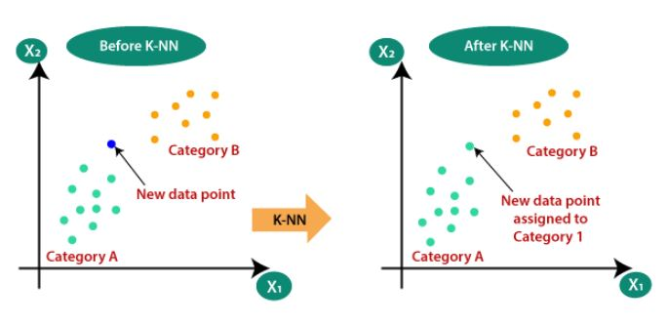

Figure 1.1 KNN Working

**Working of KNN:**

Step-1: Select the number K of the neighbours

Step-2: Calculate the Euclidean distance of K number of neighbours

Step-3: Take the K nearest neighbours as per the calculated Euclidean distance.

Step-4: Among these k neighbours, count the number of the data points in each category.

Step-5: Assign the new data points to that category for which the number of the neighbour is maximum.

Step-6: Our model is ready

**Content based filtering:**

Content-based filtering is a machine learning approach used in recommendation systems to suggest items to users based on the characteristics of the items and the preferences of the users. Instead of relying on the collaborative behaviour of users (as seen in collaborative filtering), content-based filtering considers the features or attributes of items and recommends new items that are similar to those a user has liked or interacted with in the past.

In machine learning applications, content-based filtering finds its use in various recommendation systems, such as suggesting movies, music, articles, or products to users based on their historical preferences or explicit feedback.

Using content-based filtering in machine learning models can recommend new items that align with users' tastes, making the recommendation process more personalized and potentially increasing user satisfaction and engagement.

**Chapter 2: Definition of Problem**

**2.1 Problem:**

The "Career Recommendation System" project addresses a pressing issue in the educational landscape, primarily concerning students transitioning from their 10th-grade examinations. At this critical juncture, students often find themselves at a crossroads, faced with the formidable task of choosing academic courses or streams that will significantly shape their future careers.

Even many students don't know that there are lots of different paths after 10th grade they can take for their careers instead of just studying until the 12th grade. They might not be aware that there are many other courses or options they can explore. This lack of awareness can make them miss out on discovering exciting and diverse career opportunities beyond traditional education. Helping students to understand these various paths can open up new possibilities for their futures.

However, the educational system currently also lacks a structured and comprehensive decision-making framework to guide students through this crucial phase of their academic journey.

In particular, students grapple with several challenges:

* **Lack of Systematic Guidance:** The absence of a systematic guidance system leaves many students in the dark, unsure of which path to follow. Without clear direction, they may make ill-informed decisions that can impact their career prospects for years to come.
* **Balancing Performance and Aspirations:** Striking the right balance between their academic performance, personal interests, and inherent strengths is a complex and often bewildering task. Students must align their educational choices with their career aspirations, a process that is far from straightforward.

As a result, many students are left navigating this critical decision-making process with minimal support or personalized advice. This lack of guidance can have profound consequences on their educational and career trajectories, potentially leading to mismatches between their chosen paths and their true potential.

**2.2 Background:**

The existing educational framework has long grappled with the challenge of equipping students with the tools and knowledge necessary to make informed career choices. Traditionally, students have relied on a mix of limited resources, including career counsellors and educational advisors, which often fall short of providing the personalized guidance needed.

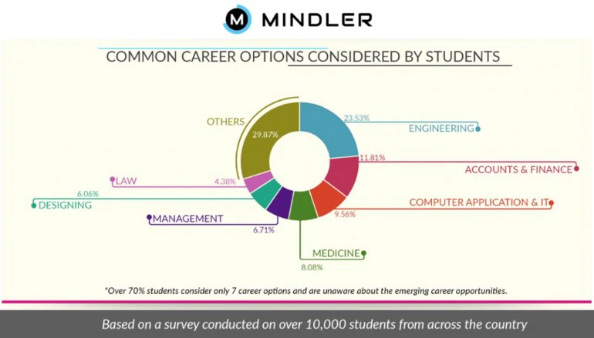A recent survey was conducted by Mindler on career option awareness among 10,000 Indian students across the country has revealed that a staggering 93% of the students aged 14 to 21 were aware of just seven career options though there are more than 250 different types of job options available in India.

Figure 2.1 Mindler Survey Graph

The complexities of aligning academic performance, personal interests, and career goals further exacerbate the problem. The evolving job market demands that students choose their paths with care, as they prepare for careers in fields that are continually changing and diversifying. Consequently, there is a growing need for an innovative solution that addresses these challenges effectively.

**2.3 Relevance:**

The "Career Recommendation System" project is profoundly relevant in the context of today's educational landscape. It directly addresses the critical issue of career decision-making for students, offering a tailored and data-driven approach to support their academic and vocational aspirations. Several key aspects underline the system's relevance:

* **Personalized Recommendations:** By leveraging data on academic performance, personal interests, and strengths, the system provides personalized course and career recommendations. This tailoring ensures that students are directed toward paths that genuinely resonate with their capabilities and aspirations.
* **Subject Weakness Mitigation:** The system goes a step further by diagnosing subject-specific weaknesses. This critical feature empowers students to address these weaknesses and bolster their educational foundations, thereby enhancing their chances of success in their chosen careers.
* **Improved Academic and Career Trajectories:** The project holds the potential to significantly improve students' academic and career trajectories. By offering precise, data-driven recommendations, it helps students make more informed decisions, reducing the likelihood of misaligned choices.

**Chapter 3: System Requirements**

**3.1 Hardware Requirements:**

* RAM: 4 Gb minimum
* Storage: 464 mb minimum

**3.2 Software Requirements:**

* Operating system platform- at least windows 10
* Database management system- SQLite
* Programming languages – Python
* Machine learning libraries and frameworks – sci-kit learn
* Data analysis tools – Pandas, NumPy
* GUI generation libraries: PyQT5, Qt designer
* IDEs: Python IDLE, Anaconda Jupyter

**Chapter 4: System Analysis & Design**

**4.1 Iterative model**

The iterative model in software engineering is an approach where the project is broken down into smaller cycles or iterations. Each iteration goes through the entire software development life cycle (SDLC), encompassing planning, design, implementation, testing, and deployment. Here's a breakdown of the steps in the iterative model:

1. **Planning:** The initial step involved outlining the project's scope and aims. Our primary goal was to develop a career recommendation system catering specifically to secondary students. Defining this scope enabled us to identify crucial functionalities for this iteration, such as data collection methods, considering academic performance as a data source, determining educational levels, and specifying the machine learning algorithm, K-Nearest Neighbours, for personalized career recommendations.
2. **Requirement Analysis:** Gather and analyze user requirements specific to the current iteration. Focus on understanding what users need for the features or functionalities planned for this cycle. In this step, we understand the perspectives, aspirations, and academic concerns of a secondary student. Analyzing their needs enabled us to design a system that addressed their academic performance, interests, and potential career paths, making the project more user-specific and relevant.
3. **Design:** Building upon the gathered requirements, the design phase involved creating a system architecture tailored to 10th-grade students' needs. This encompassed designing a database architecture that integrated academic performance metrics, crafting user interaction pages that were intuitive and accessible, and developing a system that effectively processed and analyzed academic data to generate personalized career recommendations.
4. **Implementation/Coding:** With the detailed design specifications in place, the project moved into the implementation phase. Here, the focus was on translating the design into functional components. This involved writing code for the identified features, including the recommendation model, user interaction elements like buttons and labels, and the underlying system that processed and utilized academic data to provide best possible career suggestions.
5. **Testing:** Perform testing activities such as unit testing, integration testing, and system testing. Ensure that the developed features meet the requirements and function correctly. In testing phase, manual testing was employed to identify and rectify errors and bugs encountered during this phase, ensuring a robust and reliable system.The aim was to ensure that every developed feature not only met the defined requirements but also functioned accurately and seamlessly.
6. **Evaluation/Review:** Evaluate the results and identify areas for improvement and assess whether the iteration met its goals. In this step we evaluate the result of the system and find areas for improvement to meet the objective of project.
7. **Iterations:** Repeat the cycle for the next iteration. Incorporate changes based on feedback and update the plan to address new requirements or modifications.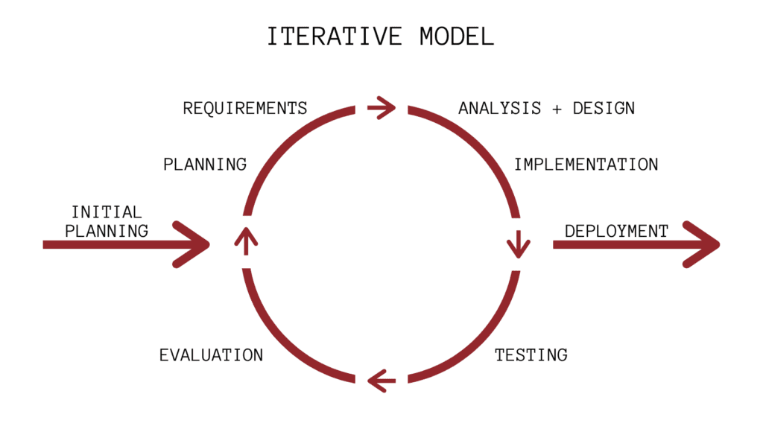

Figure 4.1 Iterative Model

**4.2 Use Case Diagram:**

A use case diagram is used to represent the dynamic behaviour of a system. It encapsulates the system's functionality by incorporating use cases, actors, and their relationships. It models the tasks, services, and functions required by a system/subsystem of an application. It depicts the high-level functionality of a system and also tells how the user handles a system.

It invokes persons, use cases, and several things that invoke the actors and elements accountable for the implementation of use case diagrams.

Following are the purposes of a use case diagram given below:

* It gathers the system's needs.
* It depicts the external view of the system.
* It recognizes the internal as well as external factors that influence the system.
* It represents the interaction between the actors.

The Use Case Diagram can be utilized in the SDLC In the following ways:

**Requirement Analysis**

* **Identification of Use Cases:** During the **Requirements Analysis phase**, Use Case Diagrams are instrumental in identifying and documenting the various use cases that represent the interactions between users (actors) and the system.
* **Defining System Scope:** The diagram helps in defining the scope of the system by showcasing the external entities (actors) and the system’s functionalities (use cases).
* **Clarifying User Requirements:** Use Case Diagrams provide a visual representation that aids in clarifying and validating user requirements with stakeholders.

**System Design**

* **Designing System Interactions:** In the **System Design phase**, Use Case Diagrams assist in designing how users (actors) will interact with the system. They help in defining the high-level functionalities and their relationships.
* **Subsystem Identification:** The diagram can be used to identify and define subsystems within the overall system, helping in organizing and modularizing the design.
* **User Interface Design:** Use Case Diagrams contribute to the design of the user interface by illustrating the main features and interactions that users will have with the system.

**Implementation**

* **Basis for Coding:** Use Case Diagrams serve as a foundation for coding by providing a clear understanding of the functionalities that need to be implemented.
* **Mapping to Code:** Each use case may be mapped to specific sections of the code during the implementation phase. The diagram helps developers understand the context and purpose of each use case.

**Testing**

* **Test Case Derivation:** Use Case Diagrams assist in deriving test cases by identifying the various scenarios and paths that need to be tested. Each use case can be a basis for creating detailed test cases.
* **Validation of System Behaviour:** Testers can use the diagrams to validate whether the system behaves as expected during different use case scenarios.

**Maintenance**

* **Change Management:**Use Case Diagrams are valuable during the maintenance phase. When there are changes in user requirements or system functionality, the diagram serves as a reference for understanding the potential impacts.
* **Documentation:**The diagram becomes a part of system documentation, aiding future development teams in understanding the system’s functionality.

**Communication**

* **Stakeholder Communication:** Throughout the SDLC, Use Case Diagrams are a valuable communication tool. They help in presenting a high-level overview of the system to stakeholders, ensuring a shared understanding of the system’s functionality.
* **Alignment with User Expectations:** By visualizing use cases, stakeholders can align their expectations with the system’s intended behaviour.

**Components of use case diagram**

* **Actors:** Actors represent the users or external entities interacting with the system. An actor can be a human user, another system, or any entity that interacts with the system. Actors are depicted as stick figures or named entities outside the system boundary.
* **Use Cases:** Use cases represent the specific functionalities or services that the system provides to its users. Each use case describes a set of actions or interactions between the user and the system to achieve a specific goal. Use cases are depicted as ovals or ellipses within the system boundary.
* **Relationships and Associations:**

1. **Association (Communication Line):** Lines connecting actors to use cases represent interactions between actors and use cases. These lines show that an actor is involved in or can trigger a particular use case.
2. **Inclusion (Include):** Indicates that one use case includes the functionality of another use case. For example, a "Login" use case might include an "Authenticate" use case.
3. **Extension (Extend):** Shows that one use case extends or adds optional behaviour to another use case under certain conditions. It signifies optional and conditional behaviour.

* **Generalization:** Represents a relationship between more general and more specific use cases, showing inheritance or specialization. It's similar to inheritance in object-oriented programming.
* **System Boundary:** The boundary or box around the use cases represents the scope or boundary of the system being modelled. It encapsulates all the use cases and actors involved within the system.

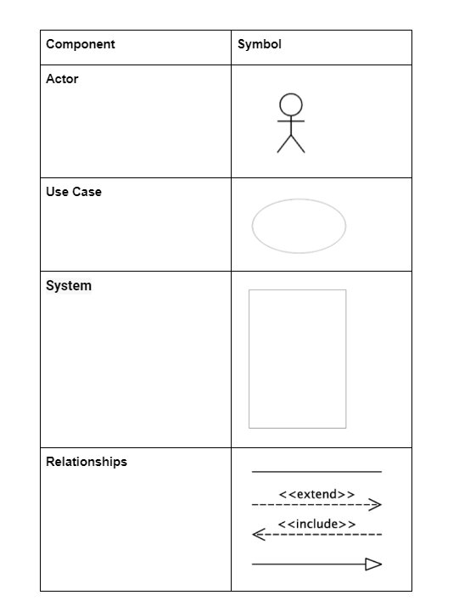

Figure 4.2 Components of use case diagrams

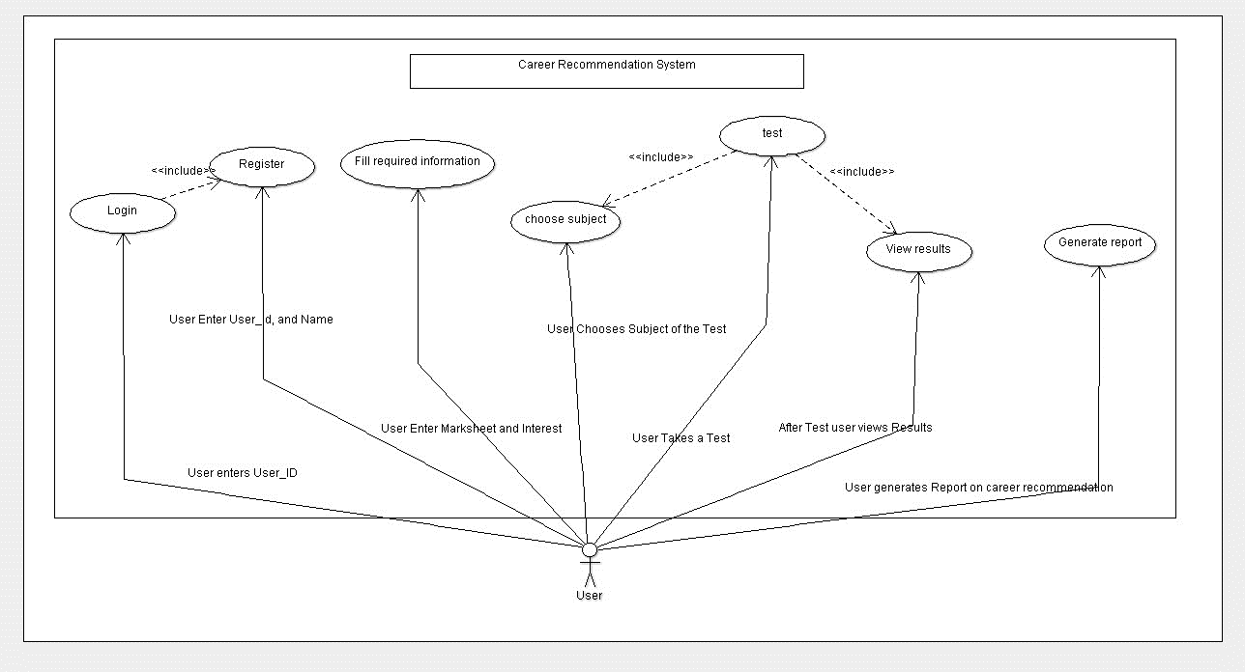

Figure 4.3 Use Case Diagram

**Explanation:**The above Diagram show how the user would interact with the system.   
**Login:** The login process would occur in a login page developed through Pyqt5 whose functionality has been connected to the database, the Login Window contains a link to the Register Window, for those who have not registered / new users.

**Register:** The register process would occur in a register page developed through Pyqt5 whose functionality has been connected to the database, the Register Window will go back to message window showing success in the Registration, the message window contains a button leading back to the Login Window.

**Fill Required Information:** The User fills their class 10 marks into the page along with their interests and submits it to the database.

**Choose Subject:** When the user decides to take the test, they first choose the subject in which they want to take a test in.

**Test:** The user after choosing the subject will begin taking the test for that subject.

**Results:** The user sees their result after taking the test which will show the result their marks out of 100.

**Generate Report**: The user clicks the Generate Report button which will direct them to a window showing them their

**Chapter 5: System Planning (PERT CHART)**

Project Evaluation and Review Technique (PERT) is a procedure through which activities of a project are represented in its appropriate sequence and timing. It is a scheduling technique used to schedule, organize and integrate tasks within a project. PERT is basically a mechanism for management planning and control which provides blueprint for a particular project. All of the primary elements or events of a project have been finally identified by the PERT. In this technique, a PERT Chart is made which represent a schedule for all the specified tasks in the project.

**Measures of PERT Chart:**

**1. Early Start (ES):** Early Start refers to the earliest possible point in time when a particular task or activity can begin. It's determined by considering the immediate predecessors of the task—activities that must be completed before it can start.

**2. Early Finish (EF):** Early Finish denotes the earliest possible point in time when a task or activity can be completed. It is calculated by adding the task duration to its Early Start time.

**3. Late Start (LS):** Late Start represents the latest point in time when a task can start without delaying the project's overall completion. It considers the project's deadline and the time required for the task.

**4. Late Finish (LF):** Late Finish indicates the latest allowable completion time for a task without impacting the project's completion date. It is determined by subtracting the task duration from its Late Start time.

**5. Slack (or Float):** Slack or Float refers to the amount of time a task can be delayed without affecting subsequent tasks or the overall project completion time. It's calculated as the difference between the Late Start and Early Start times (or Late Finish and Early Finish times) for a task.

**Components of PERT Chart:**

**Arrows:** Connects one activity to the next.

**Table:** Contains the various measure of regarding the duration of the activity and the activity’s name.

**Start:** Represents the start of the project:

**Finish:**  Represents the end the of the project.

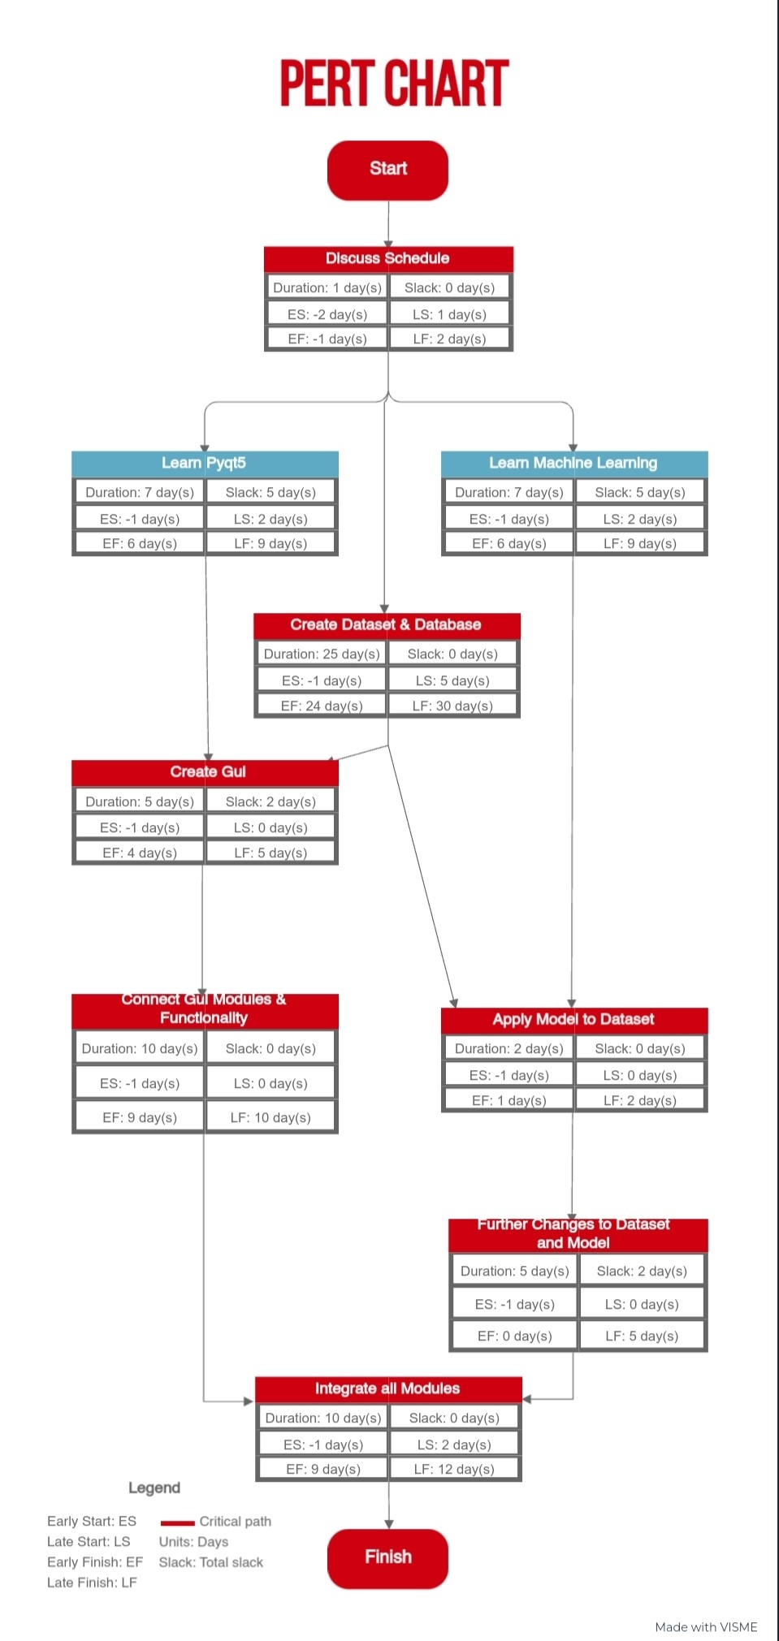

Figure 5.1 PERT Chart

**Chapter 6: Methodology**

We have followed the steps given below:

**1. Dataset creation**

In this step, we have created our own dataset which is a part of primary data collection techniques. Primary data collection is a type of data collection where data is obtained directly from the first-hand source through experiments, surveys or observations. This dataset was created using python random numbers generator function to create random number which acts as marks of student in different subjects. The datasets consist of around 12000 rows and each row contain marks of student in different subject, courses and interest. We did not perform any data filtering or data cleaning techniques because the data was created in correct form to fulfil the desired requirements of the project.

**2. Model creation**

After the datasets created successfully, we have moved towards creation of machine learning model. This model is created using KNN (K nearest neighbour) technique, a type of classification algorithm of supervised machine learning. This model recommends the best course for the user according to their marks in different subject.

**3. UI creation**

When the model creation was finished, the creation of used interface of our application started. We use Qt designer an UI designer application which provide various components for creating UI in python. It provides drag and drop feature which makes the creation of UI easy and faster. It also has a benefit which converts the .ui files into .py files. We have created so many UI pages like registration, login, menu page etc.

**4. Database Creation**

In this project we need a database to store user information such as name, marks, userid and interest. We have created two table named

**5. UI function implementation**

To make it running desktop application, we have implemented different function on various components of user interface. We can take example of user registration, if a user enters the required information on the registration page and click register button then the information of user will be store in the database and a successful registration message appears.

**6. Testing**

In testing, we have performed unit testing in each and every step of the project such as accuracy of model, buttons of user interface, etc. We have checked each programming file by taking various inputs. After the completion of unit testing, we connect the different units and then we check the working of combined units like transferring of data from one page to another page, storing of data etc.

**Chapter 7: Detail life cycle of the project**

**7.1 ERD (Entity Relationship Diagram)**

The Entity Relationship Diagram explains the relationship among the entities present in the database. ER models are used to model real-world objects like a person, a car, or a company and the relation between these real-world objects. In short, the ER Diagram is the structural format of the database.

**Components of ER diagram**

**1. Entity:** An Entity may be an object with a physical existence – a particular person, car, house, or employee – or it may be an object with a conceptual existence – a company, a job, or a university course.

* **Strong Entity:** A Strong Entity is a type of entity that has a key Attribute. Strong Entity does not depend on other Entity in the Schema. It has a primary key, that helps in identifying it uniquely, and it is represented by a rectangle. These are called Strong Entity Types.
* **Weak Entity:** An Entity type has a key attribute that uniquely identifies each entity in the entity set. But some entity type exists for which key attributes can’t be defined. These are called Weak Entity types.

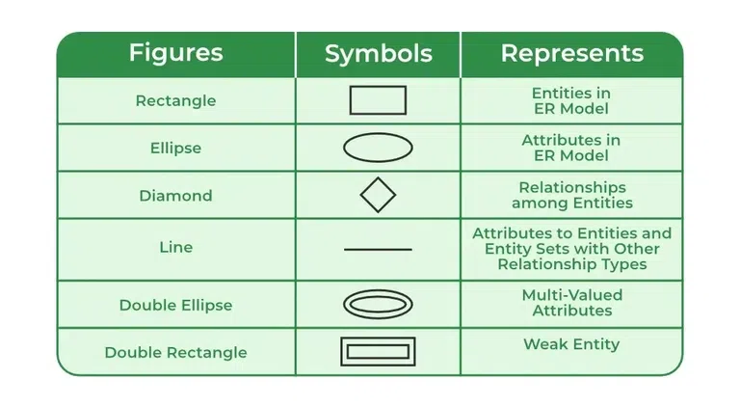

Figure 7.1 Components of ERD

**2. Attributes:** Attributes are the properties that define the entity type. For example, Roll_No, Name, DOB, Age, Address, and Mobile_No are the attributes that define entity type Student. In ER diagram, the attribute is represented by an oval.

* **Key Attribute:** The attribute which uniquely identifies each entity in the entity set is called the key attribute. For example, Roll_No will be unique for each student. In ER diagram, the key attribute is represented by an oval with underlying lines.
* **Composite Attribute:** An attribute composed of many other attributes is called a composite attribute. For example, the Address attribute of the student Entity type consists of Street, City, State, and Country. In ER diagram, the composite attribute is represented by an oval comprising of ovals.
* **Multivalued Attribute:** An attribute consisting of more than one value for a given entity. For example, Phone_No (can be more than one for a given student). In ER diagram, a multivalued attribute is represented by a double oval.
* **Derived Attribute:** An attribute that can be derived from other attributes of the entity type is known as a derived attribute. e.g.; Age (can be derived from DOB). In ER diagram, the derived attribute is represented by a dashed oval.

**Cardinality**

The number of times an entity of an entity set participates in a relationship set is known as cardinality. Cardinality can be of different types:

* **One-to-One:** When each entity in each entity set can take part only once in the relationship, the cardinality is one-to-one.
* **One-to-Many:** In one-to-many mapping as well where each entity can be related to more than one relationship and the total number of tables that can be used in this is 2.
* **Many-to-One:** When entities in one entity set can take part only once in the relationship set and entities in other entity sets can take part more than once in the relationship set, cardinality is many to one.
* **Many-to-Many:** When entities in all entity sets can take part more than once in the relationship cardinality is many to many. Let us assume that a student can take more than one course and one course can be taken by many students. So, the relationship will be many to many.

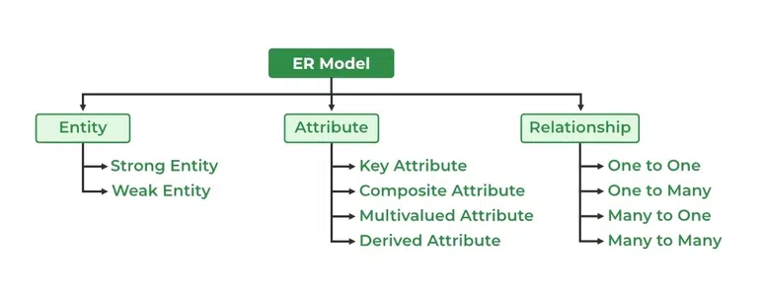

Figure 7.2 Types of all Components of ERD

**Advantages of ERD:**

* It is easy to create and understand.
* It is very simple because if you know the relationship between attributes and entities, you can easily draw it.
* It is a tool for effective communication for database designers.
* It can be easily converted into a Relational Model

**Steps to make ER diagram:**

Step 1 − Identify the entities from the given database.

Step 2 − Find relationships among entities.

Step 3 − Identify the key attribute for every entity.

Step 4 − Identify the other relevant attribute.

Step 5 − Draw the complete E-R diagram with all the attributes including primary key.

Step 6 − Review your results according to the requirements of the database.

**ER Diagram:**

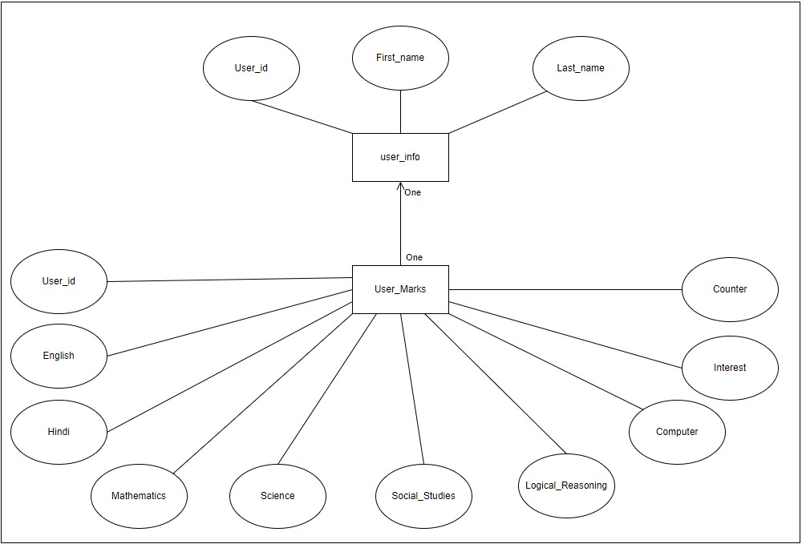

Figure 7.3 Entity Relationship Diagram

**Explanation:**

The above diagram shows the two tables created in this project and their relationship.

user_info: This table contains the attributes User_id, FirstName, LastName. The User_id is the key attribute in this table as it is the basis for tracking the session, and information of the user.

User_Marks: This table contains the attributes User_id, English, Hindi, Mathematics, Science, Social_Studies, Logical_reasoning, Computer, Interests and counter. This table stores the marksheet of the user. It is used when the user enters his information, or generates his report.

**7.2 DFD (Data Flow Diagram)**

DFD is the abbreviation for Data Flow Diagram. The flow of data of a system or a process is represented by DFD. It also gives insight into the inputs and outputs of each entity and the process itself. DFD does not have control flow and no loops or decision rules are present. Specific operations depending on the type of data can be explained by a flowchart. It is a graphical tool, useful for communicating with users ,managers and other personnel. it is useful for analyzing existing as well as proposed system.

**Components of DFD:**

* **Process:** Input to output transformation in a system takes place because of process function. The symbols of a process are rectangular with rounded corners, oval, rectangle or a circle. The process is named a short sentence, in one word or a phrase to express its essence.
* **Data Flow:** Data flow describes the information transferring between different parts of the systems. The arrow symbol is the symbol of data flow. A relatable name should be given to the flow to determine the information which is being moved. Data flow also represents material along with information that is being moved. Material shifts are modelled in systems that are not merely informative. A given flow should only transfer a single type of information. The direction of flow is represented by the arrow which can also be bi-directional.
* **Data store:** The data is stored in the data store for later use. Two horizontal lines represent the symbol of the store. The data store is simply not restricted to being a data file rather it can be anything like a folder with documents, an optical disc, a filing cabinet. The data store can be viewed independent of its implementation. When the data flow from the data store it is considered as data reading and when data flows to the data store it is called data entry or data updating.
* **Source or Sink:** The Source is an external entity that stands outside of the system and communicates with the system. It can be, for example, organizations like banks, groups of people like customers or different departments of the same organization, which is not a part of the model system and is an external entity. Modelled systems also communicate with Source.

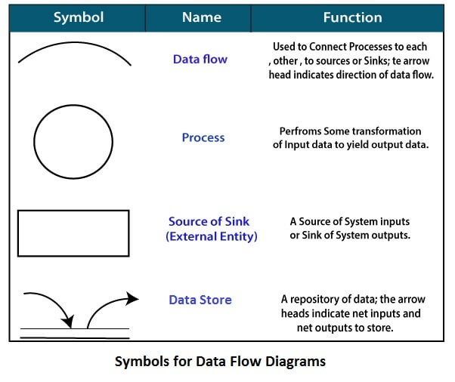

Figure 7.4 Symbols & Components of Data Flow Diagram

**Levels of DFD:**

DFD uses hierarchy to maintain transparency thus multilevel DFD’s can be created. Levels of DFD are as follows:

* **0-level DFD:** It represents the entire system as a single bubble and provides an overall picture of the system.
* **1-level DFD:** It represents the main functions of the system and how they interact with each other.
* **2-level DFD:** It represents the processes within each function of the system and how they interact with each other.
* **3-level DFD:** It represents the data flow within each process and how the data is transformed and stored.

**DFD Level 0:**

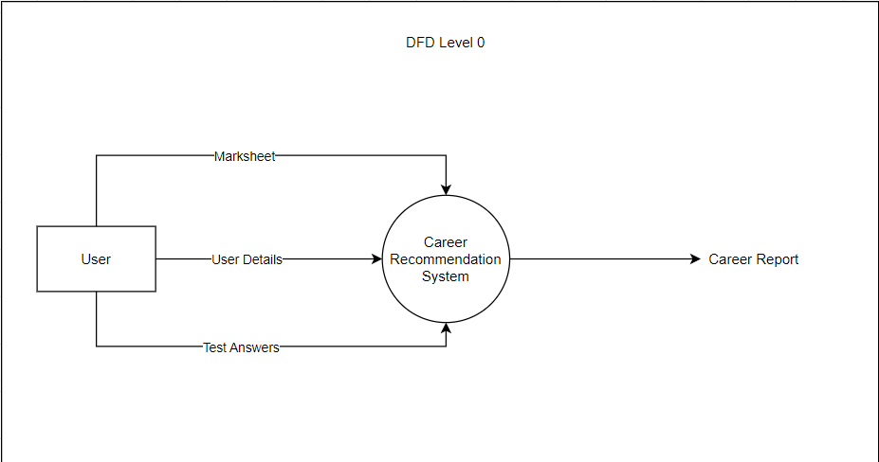

Figure 7.5 Level 0 Data Flow Diagram

**DFD Level 1:**

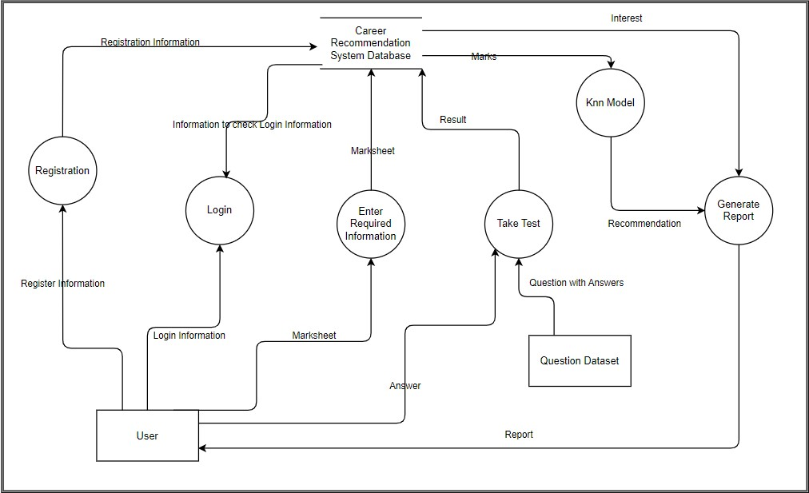

Figure 7.6 Level 1 Data Flow Diagram

**7.3 Input and output screen design**

**PyQt5**

PyQt5 is cross-platform GUI toolkit, a set of python bindings for Qt v5. One can develop an interactive desktop application with so much ease because of the tools and simplicity provided by this library. A GUI application consists of Front-end and Back-end. PyQt5 has provided a tool called ‘QtDesigner’ to design the front-end by drag and drop method so that development can become faster and one can give more time on back-end stuff.

**Here are some key features of PyQt5:**

* **Cross-platform:** Applications developed with PyQt5 can run on various operating systems like Windows, macOS, Linux, etc., without many modifications. This cross-platform capability is due to Qt's nature.
* **GUI Development:** PyQt5 provides tools and classes to design and build graphical user interfaces using Qt Designer or programmatically within Python code. It includes widgets, layouts, dialogs, and more for creating interactive interfaces.
* **Event Handling:** It allows developers to handle user interactions, events, signals, and slots effectively. This enables the creation of responsive applications by linking user actions to specific functions or methods.
* **Integration with Python:** PyQt5 seamlessly integrates with Python, allowing developers to leverage the ease of Python programming while harnessing the power of the Qt framework.
* **Support for Multimedia:** PyQt5 supports multimedia functionalities, such as playing audio and video files, thanks to Qt's multimedia modules.
* **Database Integration:** It provides tools for integrating with databases, allowing developers to create applications that interact with various database systems

**Components of pyqt5**

PyQt5 offers a range of components and classes that enable developers to create Graphical User Interfaces (GUIs) in Python. Here are some key components commonly used in PyQt5 for GUI creation:

* **Widgets:** PyQt5 provides a variety of widgets that form the building blocks of a GUI. These include:

1. **QPushButton:** Button widget for triggering actions.
2. **QLabel:** Display text or an image.
3. **QLineEdit:** Single-line text input field.
4. **QTextEdit:** Multiline text input/editing field.
5. **QCheckBox and QRadioButton:** Checkboxes and radio buttons for user selections.
6. **QComboBox and QListWidget:** Dropdown lists and list widgets for item selection.
7. **QSlider and QSpinBox:** Widgets for selecting numerical values.

* **Layout Management:** PyQt5 includes layout classes that help in organizing and arranging widgets within a window or container. Common layout classes are:

1. **QVBoxLayout and QHBoxLayout:** Vertical and horizontal box layouts.
2. **QGridLayout:** Grid-based layout for arranging widgets in rows and columns.
3. **QFormLayout**: Organizes input fields and their labels in a structured form.

* **Dialogs:** PyQt5 provides pre-built dialog windows for specific purposes, such as file dialogs, message boxes, input dialogs, and more. These include:

1. **QFileDialog:** Dialog for file selection.
2. **QMessageBox:** Dialog for displaying messages or alerts.
3. **QInputDialog:** Dialog for user input.

* **Custom Widgets:** Developers can create custom widgets by subclassing existing PyQt5 widgets or by creating entirely new ones to suit specific application needs.
* **Events and Signals:** PyQt5 uses a signals and slots mechanism to handle events and inter-widget communication. This allows actions in one widget to trigger specific functions or methods in another widget.
* **Graphics and Multimedia:** PyQt5 includes classes for working with graphics and multimedia elements, allowing developers to incorporate images, videos, and graphics within their applications.

**Qt Designer**

Qt Designer is a visual design tool provided by the Qt framework for creating graphical user interfaces (GUIs). It is part of the Qt development environment and is commonly used in conjunction with PyQt, a set of Python bindings for the Qt framework. Here are the key features of Qt Designer:

* **Visual Design:** Qt Designer allows developers to design GUIs visually by dragging and dropping UI components onto a form. This provides a WYSIWYG (What You See Is What You Get) environment, allowing designers and developers to see the appearance of the UI as they design it.
* **Widget Box:** Qt Designer provides a widget box that contains a variety of standard UI components (widgets) such as buttons, labels, text fields, and more. Developers can easily select and place these widgets on the form.
* **Layout Management:** It supports the design of complex layouts through various layout managers, including vertical and horizontal box layouts, grid layouts, and form layouts. This helps in arranging and organizing widgets within a window.
* **Property Editor:** Developers can use the property editor to customize the properties of UI components, such as their size, position, text, and appearance. This allows for fine-tuning the visual aspects of the GUI.
* **Signal and Slot Editing:** Qt Designer provides an interface for connecting signals and slots, which facilitates event handling and interaction between different UI components. This is a fundamental aspect of Qt's programming model.
* **Integration with Code Editors:** While Qt Designer is primarily a visual tool, it seamlessly integrates with code editors. Developers can easily switch between the visual design in Qt Designer and the corresponding code in their preferred integrated development environment (IDE).
* **Custom Widget Integration:** Qt Designer allows developers to integrate custom widgets into the design process. This is particularly useful when developers have created their own specialized UI components.
* **Preview Mode:** Developers can preview the appearance and behaviour of the GUI directly within Qt Designer before generating the code. This helps in identifying any design issues before deploying the application.
* **UI File Generation:** Qt Designer saves the designed UI in a .ui file format, which is an XML-based file. This file can be loaded and used by the application code, enabling the separation of UI design and logic.

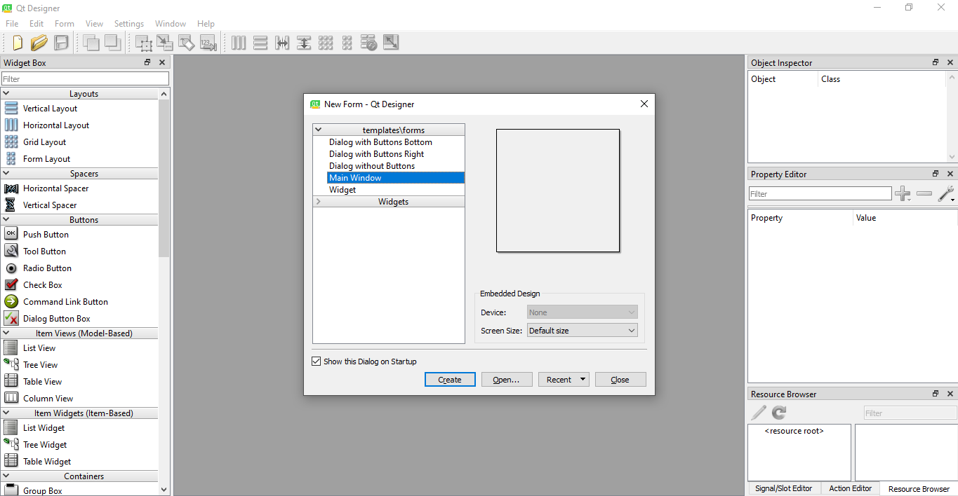

Figure 7.7 Layout of QtDesigner

**7.4 Process Involved**

**Activity Diagram**

A UML Activity diagram is a graphical representation used to model workflows and business processes within a system. It primarily focuses on the flow of activities or actions performed within a system, showcasing the sequence, conditions, and parallelism of these actions. Here are the main components of a UML Activity diagram:

* **Initial Node:** Denotes the starting point of the activity diagram. It represents the initiation of the workflow.
* **Activity or Action**: Represents a specific task or action within the system. It can be any operation, such as a calculation, decision-making process, or interaction.
* **Control Flow:** Indicates the flow or sequence of activities. It's represented by arrows connecting different activities, showing the order in which actions occur.
* **Decision or Merge Node:** Represents a branching point in the workflow where a decision is made or where different flows merge back together.
* **Fork and Join Nodes:** Fork nodes split the flow into multiple concurrent flows, while join nodes synchronize these concurrent flows back into a single flow.
* **Final Node:** Denotes the end of the activity diagram, representing the completion of the workflow.
* **Guard Condition**: Represents the condition that determines which path to follow in a decision point. It's often depicted as text near the decision node or control flow arrow.
* **Swimlanes (Partition):** Used to group activities performed by different actors or system components. They visually separate actions performed by different entities within the system.
* **Object Nodes:** Represent objects or data consumed or produced during activities.

**An activity diagram is utilized for the followings:**

1. To graphically model the workflow in an easier and understandable way.
2. To model the execution flow among several activities.
3. To model comprehensive information of a function or an algorithm employed within the system.
4. To model the business process and its workflow.
5. To envision the dynamic aspect of a system.
6. To generate the top-level flowcharts for representing the workflow of an application.
7. To represent a high-level view of a distributed or an object-oriented system.

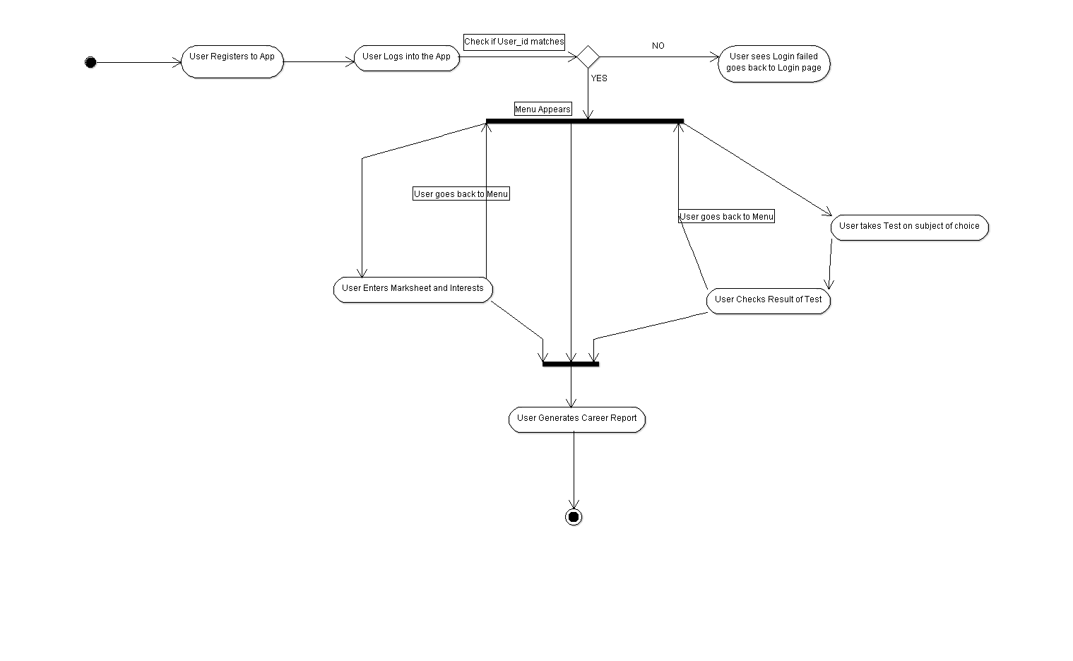

Figure 7.8 Activity Diagram

**Explanation:**

The above diagram shows the sequence and ways in which a first-time user would generally use the application.

* 1. The user will first see the login window but since the user isn’t registered, he will have to click the register button on the window and register into the application, after which he will be back to the login screen.
  2. The user will enter their User_id into the login page and the database will then send the value to check against the entered value. If the User_id doesn’t exist in the database then the user will be directed to a login failed message and then back to the login page.
  3. If the login succeeds then the user is directed to the menu, where they will do the following: enter marksheet and interest information, take a test and generate report.
  4. If the User chooses to enter their information they will be directed to a window where they can enter their marks for different subjects and choose their interest all of which would be entered into the database.
  5. If the User has entered their marks, they and are unsatisfied with their marks for certain subjects they may choose to take a test in said subject. When they choose to take a test, they will be directed to window to choose the subject on which they want to be tested. After which they would be directed to the test screen.
  6. If the user is done and satisfied with their marks, they may choose to generate the report which will take their marks and interest from the database and use the model to generate a recommendation on what field they may take a look at and what they should do in order to improve for the field they are aiming for.

**7.5 Methodology used in testing:**

**Testing:**

Software Testing is a method to assess the functionality of the software program. The process checks whether the actual software matches the expected requirements and ensures the software is bug-free. The purpose of software testing is to identify the errors, faults, or missing requirements in contrast to actual requirements. It mainly aims at measuring the specification, functionality, and performance of a software program or application.

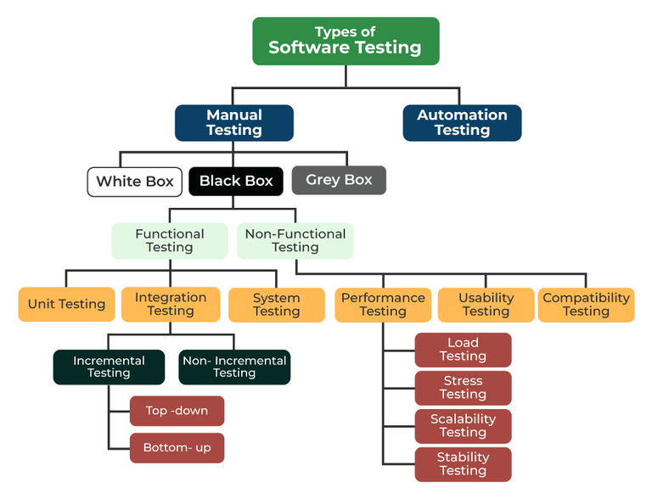

Figure 7.9 Types of Software Testing

Types of software testing:

1. Manual Testing

2. Automation Testing

**Manual Testing**

Manual testing includes testing software manually, i.e., without using any automation tool or script. In this type, the tester takes over the role of an end-user and tests the software to identify any unexpected behaviour or bug.

There are different stages for manual testing such as unit testing, integration testing, system testing, and user acceptance testing. Testers use test plans, test cases, or test scenarios to test software to ensure the completeness of testing. Manual testing also includes exploratory testing, as testers explore the software to identify errors in it.

Types of manual testing:

1. White Box

2. Black Box

3. Grey Box

**White Box**

White box testing techniques analyse the internal structures the used data structures, internal design, code structure, and the working of the software rather than just the functionality as in black box testing. It is also called glass box testing or clear box testing or structural testing. White Box Testing is also known as transparent testing or open box testing.

White box testing is a software testing technique that involves testing the internal structure and workings of a software application. The tester has access to the source code and uses this knowledge to design test cases that can verify the correctness of the software at the code level.

White box testing is also known as structural testing or code-based testing, and it is used to test the software’s internal logic, flow, and structure. The tester creates test cases to examine the code paths and logic flows to ensure they meet the specified requirements.

**7.6 Test Report:**

**Login page:**

**Test Case 1:**

Register button

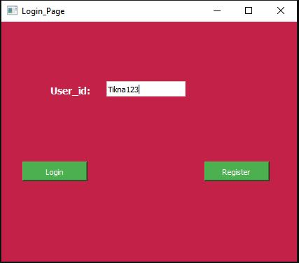

Figure 7.10 Test Report 1

**Expected Output:**

Registration page opens.

**Output:**

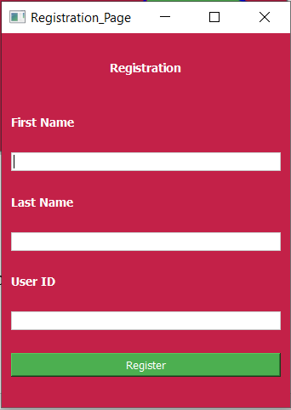

Figure 7.11 Test Report 2

**Result:** **PASS**

**Test Case 2:**

Login with correct User_id

**Expected Output:**

Menu_page opens with User_id printed in a message

**Output:**

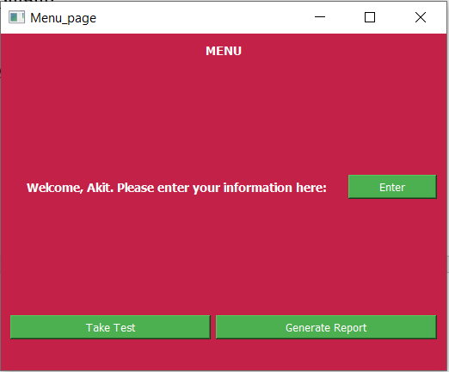

Figure 7.12 Test Report 3

**Result:** **PASS**

**Registration Page:**

**Test Case:**

Register button

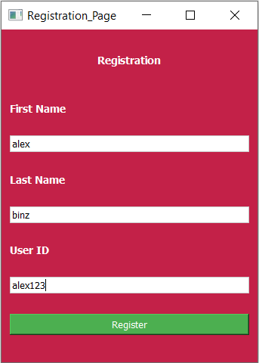

Figure 7.13 Test Report 4

**Expected Output:**

Values stored in Database and Registration successful message.

**Output:**

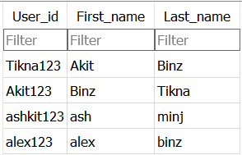

Figure 7.14 Test Report 5

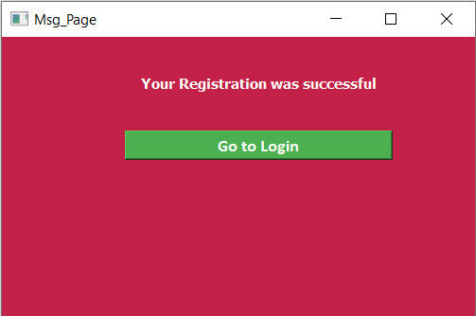

Figure 7.15 Test Report 6

**Result**: **PASS**

**Menu page:**

**Test Case 1:**

Fetchsubjects()

**Expected Output:**

77, 84, 78, 81, 91, Physical Education and Wellness, 1

**Output:**



Figure 7.16 Test Report 7

**Result:** **PASS**

**Test Case 2:**

Enter button

**Expected button:**

Enter your info page opens and with previous marks printed on it or 0

**Output:**

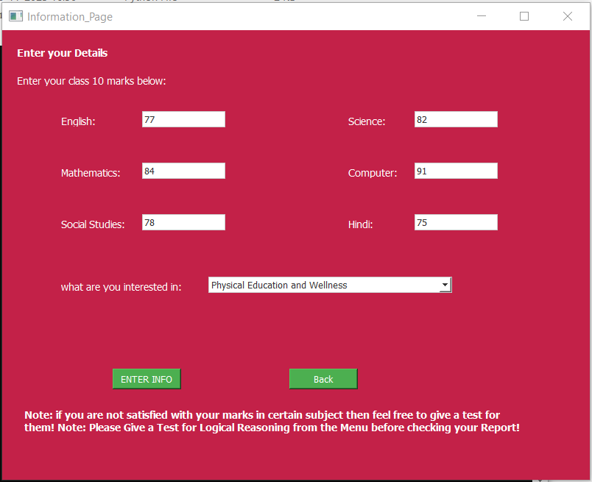

Figure 7.17 Test Report 8

**Result:** **PASS**

**Test Case 3:**

Take test button

**Expected Output:**

Choose subject page opens

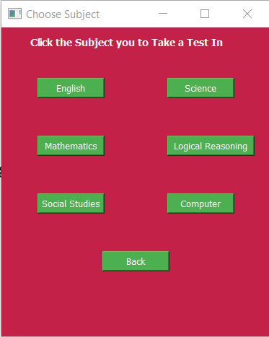**Output**:

Figure 7.18 Test Report 9

**Result:** **PASS**

**Test Case 4:**

Generate Report Button

**Expected Output:**

Generate Report Window opens with minimum report generated

**Output:**

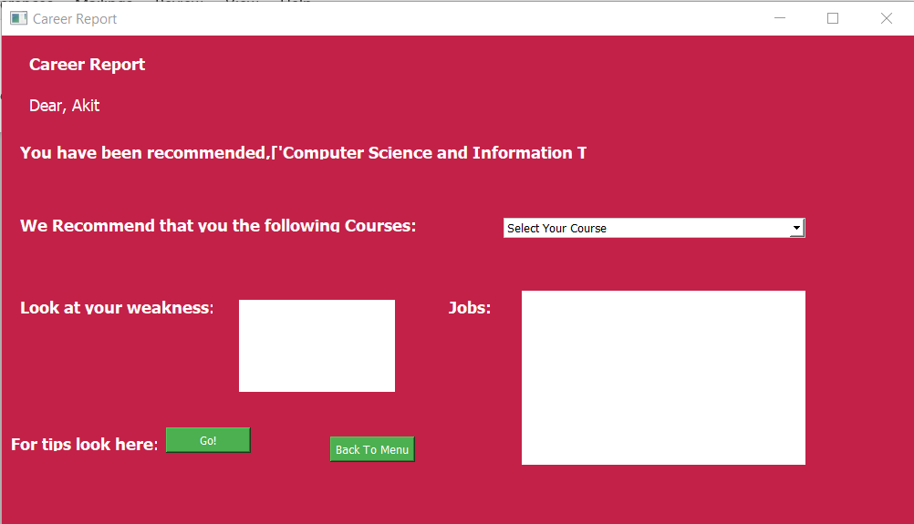

Figure 7.19 Test Report 10

**Result:** **PASS**

**Enter Info Page:**

**Test Case:**

Enter info button

**Expected Output:**

Marks get entered into database

**Output:**

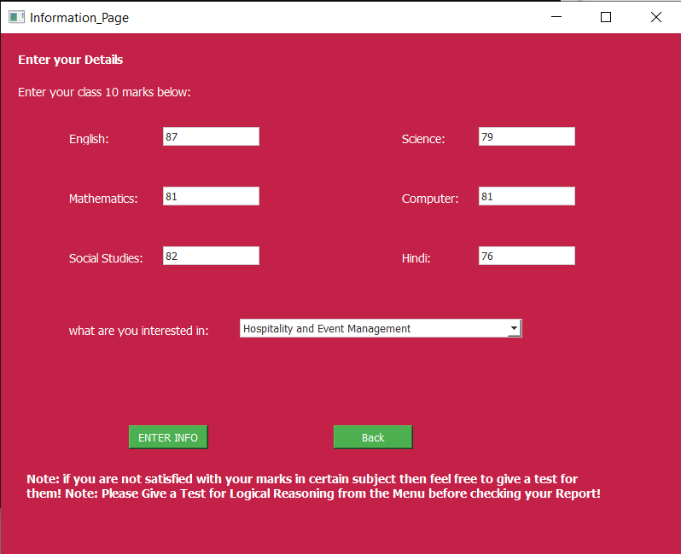

Figure 7.20 Test Report 11

**Result:** **PASS**

**Choose Subject Page:**

**Test Case:**

Subject button

**Expected Output:**

Take test page opens with question for relevant subject printed

**Output:**

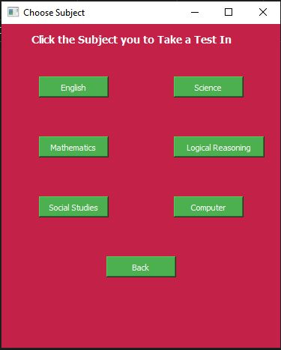

Figure 7.21 Test Report 12

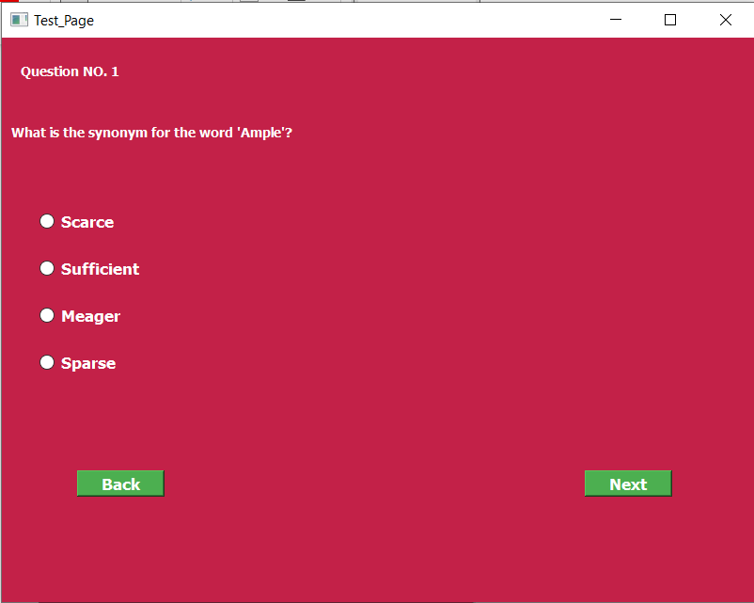

Figure 7.22 Test Report 13

**Result: PASS**

**Take Test Page:**

**Test Case 1:**

Next button

**Expected Output:**

Next question is printed on window

**Output:**

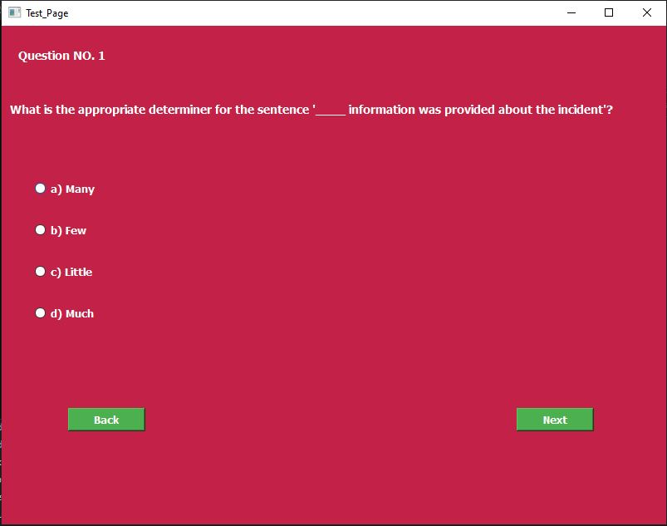

Figure 7.23 Test Report 14

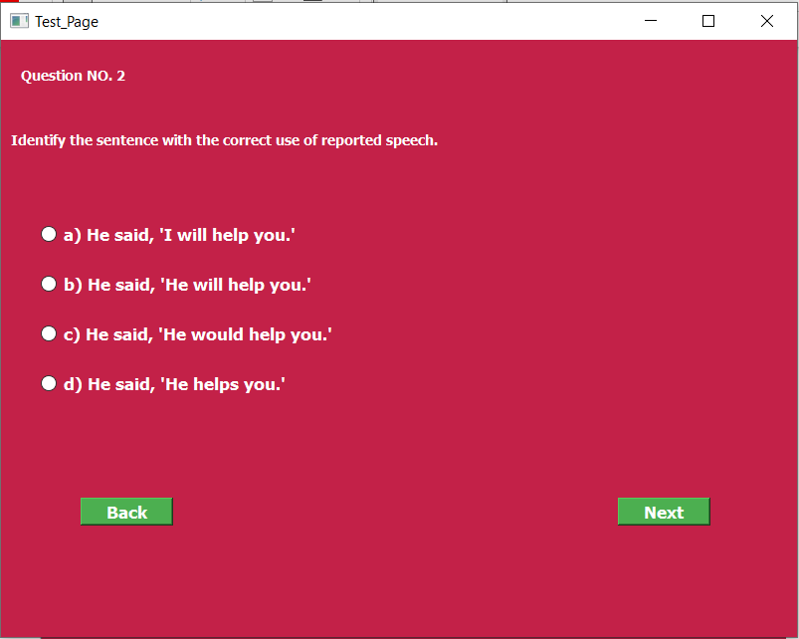

Figure 7.24 Test Report 15

**Result: PASS**

**Test Case 2:**

Back Button

**Expected Output:**

Previous Question is printed

**Output:**

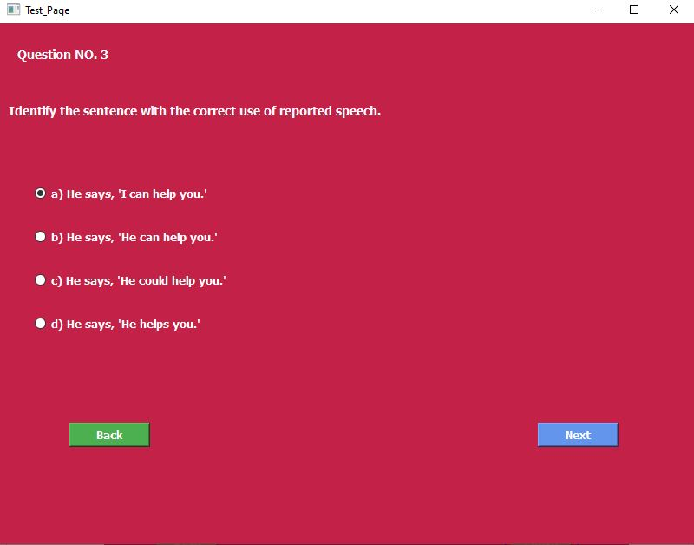

Figure 7.25 Test Report 16

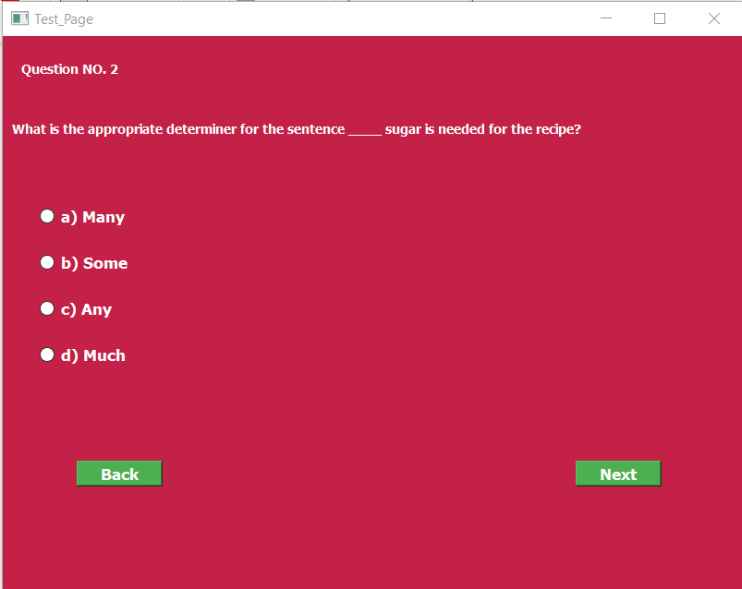

Figure 7.26 Test Report 17

**Result: PASS**

**Test Case 3:**

Finish button

**Expected Output:**

Result page is opened with result of test printed

**Output:**

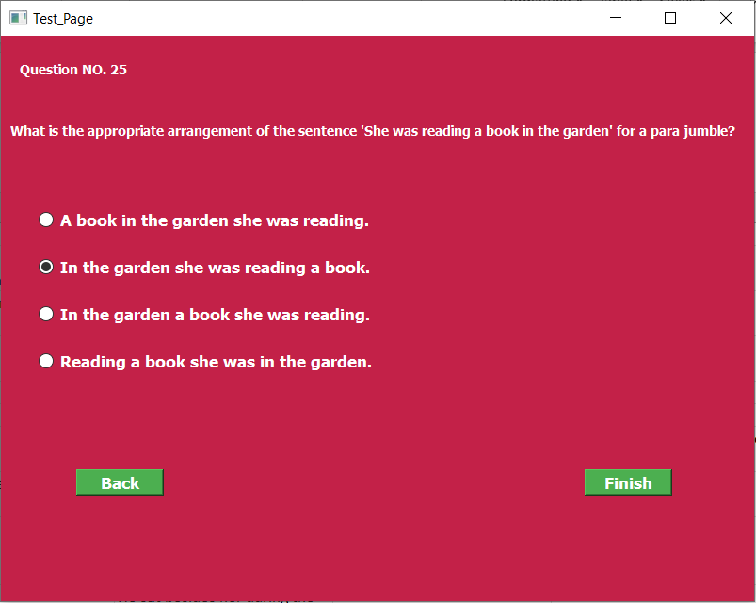

Figure 7.27 Test Report 18

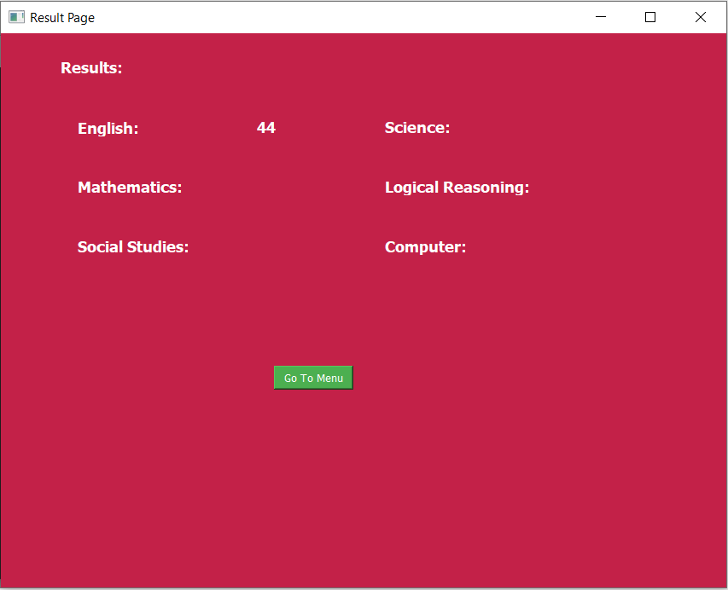

Figure 7.28 Test Report 19

**Result:** **PASS**

**Chapter 8: Code and Screenshots**

**Login page:**

from PyQt5 import QtCore, QtGui, QtWidgets

import sqlite3

import os

def find_file_path(file_name):

for root, dirs, files in os.walk(os.path.abspath(os.sep)):

if file_name in files:

return os.path.join(root, file_name)

return f"File '{file_name}' not found in the current directory "

file_path = find_file_path('Career_Recommedation_System.db')

con = sqlite3.connect(file_path)

class Ui_loginWindow(object):

def OpenRegistration(self, loginWindow):

from registration_page import Ui_RegistrationWIndow

self.window = QtWidgets.QMainWindow()

self.ui = Ui_RegistrationWIndow()

self.ui.setupUi(self.window)

self.window.show()

loginWindow.hide()

def setupUi(self, loginWindow):

education_stylesheet = """

QWidget {

background-color: #C32148;

color: white;}

QLabel {

font-family: MS Shell Dlg 2;

font-size: 14px;

font-weight: bold;

color: white;}

QPushButton {

background-color: #4CAF50;

color: white;}

QLineEdit {

background-color: #FFFFFF;

color: black;

border: 1px solid #CCCCCC;}

"""

loginWindow.setStyleSheet(education_stylesheet)

self.cur = con.cursor()

loginWindow.setObjectName("loginWindow")

loginWindow.resize(422, 343)

self.centralwidget = QtWidgets.QWidget(loginWindow)

self.centralwidget.setObjectName("centralwidget")

self.UserNameLbl = QtWidgets.QLabel(self.centralwidget)

self.UserNameLbl.setGeometry(QtCore.QRect(70, 90, 71, 16))

self.UserNameLbl.setObjectName("UserNameLbl")

self.UserNameLineEdit = QtWidgets.QLineEdit(self.centralwidget)

self.UserNameLineEdit.setGeometry(QtCore.QRect(150, 85, 113, 22))

self.UserNameLineEdit.setObjectName("UserNameLineEdit")

self.LoginButton = QtWidgets.QPushButton(self.centralwidget)

self.LoginButton.setGeometry(QtCore.QRect(30, 200, 93, 28))

self.LoginButton.setObjectName("LoginButton")

self.LoginButton.clicked.connect(lambda: self.Login(loginWindow))

self.RegisterButton = QtWidgets.QPushButton(self.centralwidget)

self.RegisterButton.setGeometry(QtCore.QRect(290, 200, 93, 28))

self.RegisterButton.setObjectName("RegisterButton")

self.RegisterButton.clicked.connect(lambda: self.OpenRegistration(loginWindow))

loginWindow.setCentralWidget(self.centralwidget)

self.menubar = QtWidgets.QMenuBar(loginWindow)

self.menubar.setGeometry(QtCore.QRect(0, 0, 422, 26))

self.menubar.setObjectName("menubar")

loginWindow.setMenuBar(self.menubar)

self.statusbar = QtWidgets.QStatusBar(loginWindow)

self.statusbar.setObjectName("statusbar")

loginWindow.setStatusBar(self.statusbar)

self.retranslateUi(loginWindow)

QtCore.QMetaObject.connectSlotsByName(loginWindow)

def retranslateUi(self, loginWindow):

_translate = QtCore.QCoreApplication.translate

loginWindow.setWindowTitle(_translate("loginWindow", "Login_Page"))

self.UserNameLbl.setText(_translate("loginWindow", "User_id:"))

self.LoginButton.setText(_translate("loginWindow", "Login"))

self.RegisterButton.setText(_translate("loginWindow", "Register"))

def gotomenu(self, loginWindow, message, name):

from menu_page import Ui_MenuWindow

self.window = QtWidgets.QMainWindow()

self.ui = Ui_MenuWindow()

self.ui.setupUi(self.window)

self.ui.LoginMsgLbl.setText(message)

self.ui.User_id = name

self.window.show()

loginWindow.hide()

def LoginMsg(self, loginWindow, message):

from after_registration import Ui_MsgWindow

self.window = QtWidgets.QMainWindow()

self.ui = Ui_MsgWindow()

self.ui.setupUi(self.window)

self.ui.RegistrationMsgLbl.setText(message)

self.window.show()

loginWindow.hide()

def fetchname(self, user_id):

statement = f"SELECT First_name from user_info WHERE User_id='{user_id}';"

self.cur.execute(statement)

result = self.cur.fetchone()

name = result[0] if result else ""

return name

def Login(self, loginWindow):

user_id = self.UserNameLineEdit.text()

statement = f"SELECT User_id from user_info WHERE User_id='{user_id}';"

self.cur.execute(statement)

if not self.cur.fetchone():

self.LoginMsg(loginWindow, "Login failed")

else:

name = self.fetchname(user_id)

self.gotomenu(loginWindow, f"Welcome, {name}. Please enter your class 10 marks here :", user_id)

if __name__ == "__main__":

import sys

app = QtWidgets.QApplication(sys.argv)

loginWindow = QtWidgets.QMainWindow()

ui = Ui_loginWindow()

ui.setupUi(loginWindow)

loginWindow.show()

sys.exit(app.exec_())

**Output:**

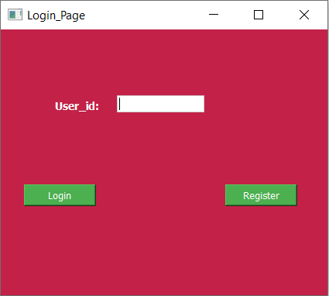

8.1 Output Screenshot

**Registeration page:**

from PyQt5 import QtCore, QtGui, QtWidgets

from after_registration import Ui_MsgWindow

import sqlite3

import os

def find_file_path(file_name):

for root, dirs, files in os.walk(os.path.abspath(os.sep)):

if file_name in files:

return os.path.join(root, file_name)

return f"File '{file_name}' not found in the current directory "

con = sqlite3.connect(find_file_path('Career_Recommedation_System.db'))

class Ui_RegistrationWIndow(object):

def setupUi(self, RegistrationWIndow):

education_stylesheet = """

QWidget {

background-color: #C32148;

color: white;

}

QLabel {

font-family: MS Shell Dlg 2;

font-size: 14px;

font-weight: bold;

color: white;

}

QPushButton {

background-color: #4CAF50;

color: white;

}

QLineEdit {

background-color: #FFFFFF;

color: black;

border: 1px solid #CCCCCC;

}

"""

RegistrationWIndow.setStyleSheet(education_stylesheet)

self.cur = con.cursor()

RegistrationWIndow.setObjectName("RegistrationWIndow")

RegistrationWIndow.resize(339, 440)

font = QtGui.QFont()

font.setFamily("Calibri")

font.setPointSize(16)

font.setBold(True)

font.setWeight(75)

RegistrationWIndow.setFont(font)

self.centralwidget = QtWidgets.QWidget(RegistrationWIndow)

self.centralwidget.setObjectName("centralwidget")

self.verticalLayout = QtWidgets.QVBoxLayout(self.centralwidget)

self.verticalLayout.setObjectName("verticalLayout")

self.splitter = QtWidgets.QSplitter(self.centralwidget)

self.splitter.setOrientation(QtCore.Qt.Horizontal)

self.splitter.setObjectName("splitter")

self.RegistrationLbl = QtWidgets.QLabel(self.splitter)

self.RegistrationLbl.setCursor(QtGui.QCursor(QtCore.Qt.ArrowCursor))

self.RegistrationLbl.setAlignment(QtCore.Qt.AlignCenter)

self.RegistrationLbl.setObjectName("RegistrationLbl")

self.verticalLayout.addWidget(self.splitter)

self.FirstNameLbl = QtWidgets.QLabel(self.centralwidget)

self.FirstNameLbl.setObjectName("FirstNameLbl")

self.verticalLayout.addWidget(self.FirstNameLbl)

self.FirstNameLineEdit = QtWidgets.QLineEdit(self.centralwidget)

self.FirstNameLineEdit.setObjectName("FirstNameLineEdit")

self.verticalLayout.addWidget(self.FirstNameLineEdit)

self.LastNameLbl = QtWidgets.QLabel(self.centralwidget)

self.LastNameLbl.setObjectName("LastNameLbl")

self.verticalLayout.addWidget(self.LastNameLbl)

self.LastNameLineEdit = QtWidgets.QLineEdit(self.centralwidget)

self.LastNameLineEdit.setObjectName("LastNameLineEdit")

self.verticalLayout.addWidget(self.LastNameLineEdit)

self.UserIdLbl = QtWidgets.QLabel(self.centralwidget)

self.UserIdLbl.setLayoutDirection(QtCore.Qt.LeftToRight)

self.UserIdLbl.setAlignment(QtCore.Qt.AlignLeading|QtCore.Qt.AlignLeft|QtCore.Qt.AlignVCenter)

self.UserIdLbl.setObjectName("UserIdLbl")

self.verticalLayout.addWidget(self.UserIdLbl)

self.UserIdLineEdit = QtWidgets.QLineEdit(self.centralwidget)

self.UserIdLineEdit.setObjectName("UserIdLineEdit")

self.verticalLayout.addWidget(self.UserIdLineEdit)

spacerItem = QtWidgets.QSpacerItem(20, 20, QtWidgets.QSizePolicy.Minimum, QtWidgets.QSizePolicy.Fixed)

self.verticalLayout.addItem(spacerItem)

self.RegisterButton = QtWidgets.QPushButton(self.centralwidget)

self.RegisterButton.setObjectName("RegisterButton")

self.RegisterButton.clicked.connect(lambda: self.Register(RegistrationWIndow))

self.verticalLayout.addWidget(self.RegisterButton)

RegistrationWIndow.setCentralWidget(self.centralwidget)

self.menubar = QtWidgets.QMenuBar(RegistrationWIndow)

self.menubar.setGeometry(QtCore.QRect(0, 0, 339, 26))

self.menubar.setObjectName("menubar")

RegistrationWIndow.setMenuBar(self.menubar)

self.statusbar = QtWidgets.QStatusBar(RegistrationWIndow)

self.statusbar.setObjectName("statusbar")

RegistrationWIndow.setStatusBar(self.statusbar)

self.retranslateUi(RegistrationWIndow)

QtCore.QMetaObject.connectSlotsByName(RegistrationWIndow)

def retranslateUi(self, RegistrationWIndow):

_translate = QtCore.QCoreApplication.translate

RegistrationWIndow.setWindowTitle(_translate("RegistrationWIndow", "Registration_Page"))

self.RegistrationLbl.setText(_translate("RegistrationWIndow", "Registration"))

self.FirstNameLbl.setText(_translate("RegistrationWIndow", "First Name"))

self.LastNameLbl.setText(_translate("RegistrationWIndow", "Last Name"))

self.UserIdLbl.setText(_translate("RegistrationWIndow", "User ID"))

self.RegisterButton.setText(_translate("RegistrationWIndow", "Register"))

def RegistrationMsg(self, RegistrationWIndow, message):

self.window = QtWidgets.QMainWindow()

self.ui = Ui_MsgWindow()

self.ui.setupUi(self.window)

self.ui.RegistrationMsgLbl.setText(message)

self.window.show()

RegistrationWIndow.hide()

def Register(self,RegistrationWIndow):

try:

firstname=self.FirstNameLineEdit.text()

lastname=self.LastNameLineEdit.text()

userid=self.UserIdLineEdit.text()

statement= f"INSERT INTO user_info VALUES('{userid}', '{firstname}', '{lastname}')"

self.cur.execute(statement)

con.commit()

self.RegistrationMsg(RegistrationWIndow, "Your Registration was successful")

except Exception as e:

errmsg=f"Error during registration: {str(e)}"

self.RegistrationMsg(RegistrationWIndow, errmsg)

if __name__ == "__main__":

import sys

app = QtWidgets.QApplication(sys.argv)

RegistrationWIndow = QtWidgets.QMainWindow()

ui = Ui_RegistrationWIndow()

ui.setupUi(RegistrationWIndow)

RegistrationWIndow.show()

sys.exit(app.exec_())

**Output:**

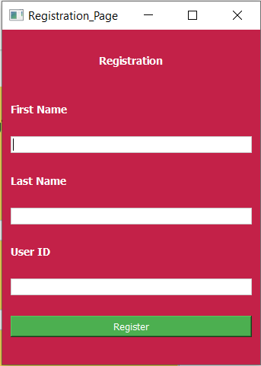

8.2 Output Screenshot 2

**Msg page:**

from PyQt5 import QtCore, QtGui, QtWidgets

class Ui_MsgWindow(object):

def OpenLogin(self,MsgWindow):

from login_page import Ui_loginWindow

self.window=QtWidgets.QMainWindow()

self.ui = Ui_loginWindow()

self.ui.setupUi(self.window)

self.window.show()

MsgWindow.hide()

def setupUi(self, MsgWindow):

education_stylesheet = """

QWidget {

background-color: #C32148;

color: white;

}

QLabel {

font-family: MS Shell Dlg 2;

font-size: 15px;

font-weight: bold;

color: white;

}

QPushButton {

background-color: #4CAF50;

color: white;

}

"""

MsgWindow.setStyleSheet(education_stylesheet)

MsgWindow.setObjectName("MsgWindow")

MsgWindow.resize(500, 489)

self.centralwidget = QtWidgets.QWidget(MsgWindow)

self.centralwidget.setObjectName("centralwidget")

self.layoutWidget = QtWidgets.QWidget(self.centralwidget)

self.layoutWidget.setGeometry(QtCore.QRect(130, 40, 283, 90))

self.layoutWidget.setObjectName("layoutWidget")

self.verticalLayout = QtWidgets.QVBoxLayout(self.layoutWidget)

self.verticalLayout.setContentsMargins(0, 0, 0, 0)

self.verticalLayout.setObjectName("verticalLayout")

self.RegistrationMsgLbl = QtWidgets.QLabel(self.layoutWidget)

font = QtGui.QFont()

font.setFamily("Calibri")

font.setPointSize(14)

self.RegistrationMsgLbl.setFont(font)

self.RegistrationMsgLbl.setAlignment(QtCore.Qt.AlignCenter)

self.RegistrationMsgLbl.setObjectName("RegistrationMsgLbl")

self.verticalLayout.addWidget(self.RegistrationMsgLbl)

spacerItem = QtWidgets.QSpacerItem(232, 27, QtWidgets.QSizePolicy.Minimum, QtWidgets.QSizePolicy.Expanding)

self.verticalLayout.addItem(spacerItem)

self.GotoLoginButton = QtWidgets.QPushButton(self.layoutWidget)

font = QtGui.QFont()

font.setFamily("Calibri")

font.setPointSize(11)

font.setBold(True)

font.setWeight(75)

self.GotoLoginButton.setFont(font)

self.GotoLoginButton.setObjectName("GotoLoginButton")

self.GotoLoginButton.clicked.connect(lambda: self.OpenLogin(MsgWindow))

self.verticalLayout.addWidget(self.GotoLoginButton)

MsgWindow.setCentralWidget(self.centralwidget)

self.menubar = QtWidgets.QMenuBar(MsgWindow)

self.menubar.setGeometry(QtCore.QRect(0, 0, 500, 26))

self.menubar.setObjectName("menubar")

MsgWindow.setMenuBar(self.menubar)

self.statusbar = QtWidgets.QStatusBar(MsgWindow)

self.statusbar.setObjectName("statusbar")

MsgWindow.setStatusBar(self.statusbar)

self.retranslateUi(MsgWindow)

QtCore.QMetaObject.connectSlotsByName(MsgWindow)

def retranslateUi(self, MsgWindow):

_translate = QtCore.QCoreApplication.translate

MsgWindow.setWindowTitle(_translate("MsgWindow", "Msg_Page"))

self.RegistrationMsgLbl.setText(_translate("MsgWindow", "Registration message"))

self.GotoLoginButton.setText(_translate("MsgWindow", "Go to Login"))

if __name__ == "__main__":

import sys

app = QtWidgets.QApplication(sys.argv)

MsgWindow = QtWidgets.QMainWindow()

ui = Ui_MsgWindow()

ui.setupUi(MsgWindow)

MsgWindow.show()

sys.exit(app.exec_())

**Output:**



8.3 Output Screenshot 3

**Menu page:**

from PyQt5 import QtCore, QtGui, QtWidgets

from PyQt5.QtWidgets import QMessageBox

from model import Printpred, PrintBranch

import pandas as pd

import numpy as np

import pickle

import sqlite3

import os

def find_file_path(file_name):

for root, dirs, files in os.walk(os.path.abspath(os.sep)):

if file_name in files:

return os.path.join(root, file_name)

return f"File '{file_name}' not found"

career = pd.read_excel(find_file_path('student_marksheet_final3.xlsx'))

con = sqlite3.connect(find_file_path('Career_Recommedation_System.db'))

class Ui_MenuWindow(object):

def setupUi(self, MenuWindow):

self.diploma = {

"Computer Science and Information Technology (Diploma)":

["Diploma in Computer Science",

"Diploma in Digital Marketing",

"Diploma in Mobile App Development",

"Diploma in Cybersecurity",

"Diploma in Web Development"

],

"Mechanical and Electrical (Diploma)":

["Diploma in Mechanical Engineering",

"Diploma in Electrical Engineering",

"Diploma in Automobile Engineering",

"Diploma in Chemical Engineering",

],

"Electronics and Communication (Diploma)":[

"Diploma in Electronics and Communication"

],

"Construction and Design (Diploma)":[

"Diploma in Architecture",

"Diploma in Civil Engineering",

"Diploma in Interior Design"

],

"Hospitality and Event Management (Diploma)":[

"Diploma in Hotel Management",

"Diploma in Event Management",

"Diploma in Aviation and Hospitality Management"

],

"Life Sciences and Environment (Diploma)":[

"Diploma in Biotechnology",

"Diploma in Environmental Science",

"Diploma in Veterinary Science"

],

"Arts and Media (Diploma)":[

"Diploma in Animation and Multimedia",

"Diploma in Film Making and Direction",

"Diploma in Photography"

],

"Physical Education and Wellness (Diploma)":[

"Diploma in Early Childhood Education",

"Diploma in Yoga and Wellness"

],

"Finance, Business and Marketing (Diploma)":[

"Diploma in Financial Accounting"

]

}

self.iti = {

"Computer Science and Information Technology (ITI)":[

"ITI in Computer Hardware and Networking",

"ITI in Information Technology",

"ITI in Mobile Repair and Maintenance"

],

"Mechanical and Electrical (ITI)":[

"ITI in Mechanical",

"ITI in Automotive Technology",

"ITI in Welding and Fabrication",

"ITI in Fitter and Turner",

"ITI in Machinist",

"ITI in Foundry and Pattern Making",

"ITI in CNC Operator"

],

"Electronics and Communication (ITI)":[

"ITI in Electronics and Communication",

"ITI in Instrumentation and Control",

],

"Construction and Design (ITI)":[

"ITI in Plumbing and Pipefitting",

"ITI in Carpentry and Woodworking"

],

"Physical Education and Wellness (ITI)":[

"ITI in Beauty and Wellness"

]

}

self.vocational = {"Computer Science and Information Technology (Vocational)":[

"Vocational Training in Data Entry and Office Automation",

"Vocational Training in Computer Programming",

"Vocational Training in Mobile App Development",

"Vocational Training in Web Development",

"Vocational Training in Computer Hardware and Networking",

"Vocational Training in Mobile Phone Repair Technician"

],

"Mechanical and Electrical (Vocational)": [

"Vocational Training in Welding Technician",

"Vocational Training in Automotive Technician",

"Vocational Training in Electrician",

"Vocational Training in AutoCAD and Drafting Certification",

"Vocational Training in Robotics and Automation Workshop",

"Vocational Training in Machinist and CNC Operator",

" Vocational Training in HVAC Technician"

],

"Construction and Design (Vocational)": [

"Vocational Training in Welding Technician",

"Vocational Training in Plumbing and Pipefitting",

"Vocational Training in Carpentry and Woodworking"

],

"Hospitality and Event Management (Vocational)": [

"Vocational Training in Hospitality and Customer Service",

"Vocational Training in Healthcare Assistant Training",

"Vocational Training in Basic First Aid and Safety Training",

"Vocational Training in Retail Sales and Customer Service"

],

"Arts and Media (Vocational)": [

"Vocational Training in Graphic design Essentials",

"Vocational Training in Digital Marketing Certification",

"Vocational Training in Photography and Videography Course",

"Vocational Training in Fashion Design and Tailoring",

"Vocational Training in Language Proficiency Course"

],

"Physical Education and Wellness (Vocational)":

"Vocational Training in Beauty and Makeup Artistry"

,

"Finance, Business and Marketing (Vocational)":

[

"Vocational Training in Digital Marketing Certification",

"Vocational Training in Entrepreneurship and Business Skills"

],

"Culinary Studies and Cooking (Vocational)":

[

"Vocational Training in Culinary arts and Cooking",

"Vocational Training in Baking and Pastry Arts",

"Vocational Training in Food Safety and Hygiene Certification"

]

}

self.ITIReq = {"Computer Science and Information Technology":[60,65,60,40,60,65],

"Mechanical and Electrical":[60,65,65,40,60,60],

"Electronics and Communication":[60,65,65,40,56,60],

"Construction and Design":[60,65,65,40,60,56],

"Physical Education and Wellness":[65,60,65,40,60,56]}

self.DiplomaReq = {"Computer Science and Information and technology":[75,81,75,40,75,81] ,

"Mechanical and Electrical":[75,81,81,40,75,75],

"Electronics and Communication":[75,75,81,40,75,81],

"Construction and Design":[75,75,75,81,81,75],

"Hospitality and Event Management":[81,40,40,81,75,75],

"Life Sciences and Environment":[75,75,81,40,40,40],

"Arts and Media":[81,40,40,81,75,75],

"Physical Education and Wellness":[81,40,81,40,75,75],

"Finance, Business and Marketing":[81,81,40,40,81,75]}

education_stylesheet = """

QWidget {

background-color: #C32148;

color: white;

}

QLabel {

font-family: MS Shell Dlg 2;

font-size: 14px;

font-weight: bold;

color: white;

}

QPushButton {

background-color: #4CAF50;

color: white;

}

"""

MenuWindow.setStyleSheet(education_stylesheet)

self.cur = con.cursor()

self.User_id = ""

MenuWindow.setObjectName("MenuWindow")

MenuWindow.resize(518, 391)

font = QtGui.QFont()

font.setPointSize(7)

font.setBold(True)

font.setWeight(75)

MenuWindow.setFont(font)

self.centralwidget = QtWidgets.QWidget(MenuWindow)

self.centralwidget.setObjectName("centralwidget")

self.horizontalLayout = QtWidgets.QHBoxLayout(self.centralwidget)

self.horizontalLayout.setObjectName("horizontalLayout")

self.verticalLayout = QtWidgets.QVBoxLayout()

self.verticalLayout.setObjectName("verticalLayout")

self.label = QtWidgets.QLabel(self.centralwidget)

font = QtGui.QFont()

font.setFamily("MS Shell Dlg 2")

font.setPointSize(14)

font.setBold(True)

font.setWeight(75)

self.label.setFont(font)

self.label.setAlignment(QtCore.Qt.AlignCenter)

self.label.setObjectName("label")

self.verticalLayout.addWidget(self.label)

spacerItem = QtWidgets.QSpacerItem(276, 13, QtWidgets.QSizePolicy.Minimum, QtWidgets.QSizePolicy.Expanding)

self.verticalLayout.addItem(spacerItem)

self.splitter_2 = QtWidgets.QSplitter(self.centralwidget)

self.splitter_2.setOrientation(QtCore.Qt.Horizontal)

self.splitter_2.setObjectName("splitter_2")

self.LoginMsgLbl = QtWidgets.QLabel(self.splitter_2)

font = QtGui.QFont()

font.setFamily("MS Shell Dlg 2")

font.setPointSize(9)

font.setBold(False)

font.setWeight(50)

self.LoginMsgLbl.setFont(font)

self.LoginMsgLbl.setAlignment(QtCore.Qt.AlignCenter)

self.LoginMsgLbl.setObjectName("LoginMsgLbl")

self.EnterButton = QtWidgets.QPushButton(self.splitter_2)

font = QtGui.QFont()

font.setFamily("MS Shell Dlg 2")

font.setPointSize(8)

font.setBold(False)

font.setWeight(50)

self.EnterButton.setFont(font)

self.EnterButton.setObjectName("EnterButton")

self.EnterButton.clicked.connect(lambda: self.infopage(MenuWindow))

self.verticalLayout.addWidget(self.splitter_2)

spacerItem1 = QtWidgets.QSpacerItem(269, 6, QtWidgets.QSizePolicy.Minimum, QtWidgets.QSizePolicy.Expanding)

self.verticalLayout.addItem(spacerItem1)

self.splitter = QtWidgets.QSplitter(self.centralwidget)

self.splitter.setOrientation(QtCore.Qt.Horizontal)

self.splitter.setObjectName("splitter")

self.TakeTestButton = QtWidgets.QPushButton(self.splitter)

font = QtGui.QFont()

font.setFamily("MS Shell Dlg 2")

font.setPointSize(8)

font.setBold(False)

font.setWeight(50)

self.TakeTestButton.setFont(font)

self.TakeTestButton.setObjectName("TakeTestButton")

self.TakeTestButton.clicked.connect(lambda: self.ChooseSub(MenuWindow))

self.GenerateReportButton = QtWidgets.QPushButton(self.splitter)

font = QtGui.QFont()

font.setFamily("MS Shell Dlg 2")

font.setPointSize(8)

font.setBold(False)

font.setWeight(50)

self.GenerateReportButton.setFont(font)

self.GenerateReportButton.setObjectName("GenerateReportButton")

self.GenerateReportButton.clicked.connect(lambda: self.clicked_generate_report(MenuWindow))

self.verticalLayout.addWidget(self.splitter)

self.horizontalLayout.addLayout(self.verticalLayout)

MenuWindow.setCentralWidget(self.centralwidget)

self.menubar = QtWidgets.QMenuBar(MenuWindow)

self.menubar.setGeometry(QtCore.QRect(0, 0, 518, 26))

self.menubar.setObjectName("menubar")

MenuWindow.setMenuBar(self.menubar)

self.statusbar = QtWidgets.QStatusBar(MenuWindow)

self.statusbar.setObjectName("statusbar")

MenuWindow.setStatusBar(self.statusbar)

self.retranslateUi(MenuWindow)

QtCore.QMetaObject.connectSlotsByName(MenuWindow)

def retranslateUi(self, MenuWindow):

_translate = QtCore.QCoreApplication.translate

MenuWindow.setWindowTitle(_translate("MenuWindow", "Menu_page"))

self.label.setText(_translate("MenuWindow", "MENU"))

self.LoginMsgLbl.setText(_translate("MenuWindow", "Enter your class 10 marks here :"))

self.EnterButton.setText(_translate("MenuWindow", "Enter"))

self.TakeTestButton.setText(_translate("MenuWindow", "Take Test"))

self.GenerateReportButton.setText(_translate("MenuWindow", "Generate Report"))

def fetchsubjects(self):

user_id = self.User_id

statement = f"SELECT English, Hindi, Mathematics, Social_Studies, Science, Computer, Interests, counter from User_Marks WHERE User_id='{user_id}';"

try:

self.cur.execute(statement)

result = self.cur.fetchone()

if result:

english, hindi, mathematics, social_studies, science, computer, interests, counter = result

else:

english, hindi, mathematics, social_studies, science, computer, interests, counter = 0, 0, 0, 0, 0, 0, "Select", 0

return english, hindi, mathematics, social_studies, science, computer, interests, counter

except sqlite3.Error as e:

error_message = f"Database error: {e}"

QMessageBox.critical(None, "Error", error_message, QMessageBox.Ok)

return 0, 0, 0, 0, 0, 0, "Select", 0

def fetchallsubjects(self):

user_id = self.User_id

statement = f"SELECT English, Mathematics, Science, Social_Studies, Logical_Reasoning, Computer, Interests from User_Marks WHERE User_id='{user_id}';"

try:

self.cur.execute(statement)

result = self.cur.fetchone()

if result:

english, mathematics, science, social_studies, logical_reasoning, computer, interests = result

else:

english, mathematics, science, social_studies, logical_reasoning, computer, interests = 0, 0, 0, 0, 0, 0, "Select"

return english, mathematics, science, social_studies, logical_reasoning, computer, interests

except sqlite3.Error as e:

error_message = f"Database error: {e}"

QMessageBox.critical(None, "Error", error_message, QMessageBox.Ok)

return 0, 0, 0, 0, 0, 0, "Select"

def infopage(self, MenuWindow):

from Enter_Your_Info import Ui_EnterInfoWindow

self.window = QtWidgets.QMainWindow()

self.ui = Ui_EnterInfoWindow()

self.ui.setupUi(self.window)

self.ui.User_id = self.User_id

english, hindi, mathematics, social_studies, science, computer, interests, counter = self.fetchsubjects()

self.ui.EnglishLineEdit.setText(f"{english}")

self.ui.HindiLineEdit.setText(f"{hindi}")

self.ui.MathsLineEdit.setText(f"{mathematics}")

self.ui.SstLineEdit.setText(f"{social_studies}")

self.ui.ScienceLineEdit.setText(f"{science}")

self.ui.InterestsCB.setCurrentText(f"{interests}")

self.ui.counter = counter

self.window.show()

MenuWindow.hide()

def ChooseSub(self, MenuWindow):

from Choose_Subject import Ui_SubjectWindow

self.window = QtWidgets.QMainWindow()

self.ui = Ui_SubjectWindow()

self.ui.setupUi(self.window)

self.ui.User_id = self.User_id

self.window.show()

MenuWindow.hide()

def fetchname(self, user_id):

statement = f"SELECT First_name from user_info WHERE User_id='{user_id}';"

self.cur.execute(statement)

result = self.cur.fetchone()

name = result[0] if result else ""

return name

def clicked_generate_report(self, MenuWindow):

recommend = ""

courses = []

branch = 0

ITIsubs = []

Diplomasubs = []

weaksubs = []

english, mathematics, science, social_studies, logical_reasoning, computer, interests = self.fetchallsubjects()

ITIsubs = [english,mathematics,science,logical_reasoning,computer]

Diplomasubs = [english,mathematics,science,social_studies,logical_reasoning,computer]

recommend, courses, branch = self.Gencourses()

if branch == 0:

weaksubs = self.CheckRequirementsDiploma(interests,Diplomasubs)

if branch == 1 and interests in self.ITIReq:

weaksubs = self.CheckRequirementsITI(interests,ITIsubs)

else:

weaksubs = []

self.GenReport(MenuWindow, recommend, courses, branch, weaksubs)

def Gencourses(self):

english, mathematics, science, social_studies, logical_reasoning, computer, interests = self.fetchallsubjects()

branch = PrintBranch(english, mathematics, science, social_studies, logical_reasoning, computer)

recommend = Printpred(english, mathematics, science, social_studies, logical_reasoning, computer, branch)

recommend = str(recommend).strip("['']")

courses = []

if "(Diploma)" in recommend:

if recommend in self.diploma:

courses = self.diploma[recommend]

elif "(ITI)" in recommend:

if recommend in self.iti:

courses = self. iti[recommend]

else:

if recommend in self.vocational:

courses =self. vocational[recommend]

return recommend, courses, branch

def CheckRequirementsITI(self,interest,subs):

weaksubs = []

for i in range(5):

if self.ITIReq[interest][i] > subs[i]:

if i == 0:

weaksubs.append("English")

if i == 1:

weaksubs.append("Mathematics")

if i == 2:

weaksubs.append("Science")

if i == 3:

weaksubs.append("Logical_Reasoning")

if i == 4:

weaksubs.append("Computer")

return weaksubs

def CheckRequirementsDiploma(self,interest,subs):

weaksubs = []

for i in range(6):

if self.DiplomaReq[interest][i] > subs[i]:

if i == 0:

weaksubs.append("English")

if i == 1:

weaksubs.append("Mathematics")

if i == 2:

weaksubs.append("Science")

if i == 3:

weaksubs.append("Social_Studies")

if i == 4:

weaksubs.append("Logical_Reasoning")

if i == 5:

weaksubs.append("Computer")

return weaksubs

def GenReport(self, MenuWindow, recommend, courses, branch, weaksubs):

from GenerateReport import Ui_ReportWindow

temp = ""

self.window = QtWidgets.QMainWindow()

self.ui = Ui_ReportWindow()

self.ui.setupUi(self.window)

self.ui.User_id = self.User_id

name = self.fetchname(self.User_id)

self.ui.StrtMsgLbl.setText(f"Dear, {name}")

self.ui.RecomendLbl.setText(f"You have been recommended,{recommend}")

if type(courses) is list:

for i in range(len(courses)):

self.ui.RecomCB.setItemText(i+1,f"{courses[i]}")

else:

self.ui.RecomCB.setItemText(1,f"{courses}")

for i in range(len(weaksubs)):

temp = "\n".join(weaksubs)

self.ui.WeakLbl.setText(temp)

self.ui.Branch = branch

self.ui.weaksubs = weaksubs

self.window.show()

MenuWindow.hide()

if __name__ == "__main__":

import sys

app = QtWidgets.QApplication(sys.argv)

MenuWindow = QtWidgets.QMainWindow()

ui = Ui_MenuWindow()

ui.setupUi(MenuWindow)

MenuWindow.show()

sys.exit(app.exec_())

**Output:**

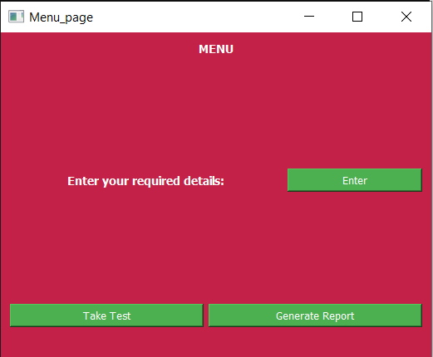

8.4 Output Screenshot 4

**Information page:**

from PyQt5 import QtCore, QtGui, QtWidgets

import sqlite3

import os

def find_file_path(file_name):

for root, dirs, files in os.walk(os.path.abspath(os.sep)):

if file_name in files:

return os.path.join(root, file_name)

return f"File '{file_name}' not found in the current directory "

con = sqlite3.connect(find_file_path('Career_Recommedation_System.db'))

class Ui_EnterInfoWindow(object):

def setupUi(self, EnterInfoWindow):

education_stylesheet = """

QWidget {

background-color: #C32148;

color: white;

}

QLabel {

font-family: MS Shell Dlg 2;

font-size: 14px;

color: white;

}

QLineEdit{

background-color: #FFFFFF;

color: #333333;

border: 1px solid #CCCCCC;

}

QComboBox {

background-color: #FFFFFF;

color: #333333;

border: 1px solid #CCCCCC;

}

QComboBox QAbstractItemView {

background-color: #FFFFFF;

color: #333333;

border: 1px solid #CCCCCC;

}

QComboBox QAbstractItemView::up-arrow, QComboBox QAbstractItemView::down-arrow {

background-color: #FFFFFF;

}

QComboBox QScrollBar:vertical {

background-color: #FFFFFF;

}

QPushButton {

background-color: #4CAF50;

color: white;

}

"""

EnterInfoWindow.setStyleSheet(education_stylesheet)

self.cur = con.cursor()

self.counter = 0

self.User_id = ""

EnterInfoWindow.setObjectName("EnterInfoWindow")

EnterInfoWindow.resize(798, 611)

self.centralwidget = QtWidgets.QWidget(EnterInfoWindow)

self.centralwidget.setObjectName("centralwidget")

self.EnterInfoButton = QtWidgets.QPushButton(self.centralwidget)

self.EnterInfoButton.setGeometry(QtCore.QRect(150, 460, 93, 28))

self.EnterInfoButton.setObjectName("EnterInfoButton")

self.EnterInfoButton.clicked.connect(lambda: self.EnterInfo(self.User_id))

self.BackButton = QtWidgets.QPushButton(self.centralwidget)

self.BackButton.setGeometry(QtCore.QRect(390, 460, 93, 28))

self.BackButton.setObjectName("BackButton")

self.BackButton.clicked.connect(lambda: self.Back(EnterInfoWindow))

self.label = QtWidgets.QLabel(self.centralwidget)

self.label.setGeometry(QtCore.QRect(20, 10, 500, 41))

font = QtGui.QFont()

font.setPointSize(10)

font.setBold(True)

font.setWeight(75)

self.label.setFont(font)

self.label.setObjectName("label")

self.label_2 = QtWidgets.QLabel(self.centralwidget)

self.label_2.setGeometry(QtCore.QRect(80, 115, 71, 16))

self.label_2.setObjectName("label_2")

self.EnglishLineEdit = QtWidgets.QLineEdit(self.centralwidget)

self.EnglishLineEdit.setGeometry(QtCore.QRect(190, 110, 113, 22))

self.EnglishLineEdit.setObjectName("EnglishLineEdit")

self.label_3 = QtWidgets.QLabel(self.centralwidget)

self.label_3.setGeometry(QtCore.QRect(80, 185, 81, 16))

self.label_3.setObjectName("label_3")

self.MathsLineEdit = QtWidgets.QLineEdit(self.centralwidget)

self.MathsLineEdit.setGeometry(QtCore.QRect(190, 180, 113, 22))

self.MathsLineEdit.setObjectName("MathsLineEdit")

self.label_4 = QtWidgets.QLabel(self.centralwidget)

self.label_4.setGeometry(QtCore.QRect(80, 255, 91, 16))

self.label_4.setObjectName("label_4")

self.SstLineEdit = QtWidgets.QLineEdit(self.centralwidget)

self.SstLineEdit.setGeometry(QtCore.QRect(190, 250, 113, 22))

self.SstLineEdit.setObjectName("SstLineEdit")

self.label_5 = QtWidgets.QLabel(self.centralwidget)

self.label_5.setGeometry(QtCore.QRect(470, 115, 55, 16))

self.label_5.setObjectName("label_5")

self.ScienceLineEdit = QtWidgets.QLineEdit(self.centralwidget)

self.ScienceLineEdit.setGeometry(QtCore.QRect(560, 110, 113, 22))

self.ScienceLineEdit.setObjectName("ScienceLineEdit")

self.label_h = QtWidgets.QLabel(self.centralwidget)

self.label_h.setGeometry(QtCore.QRect(470, 185, 61, 16))

self.label_h.setObjectName("label_h")

self.HindiLineEdit = QtWidgets.QLineEdit(self.centralwidget)

self.HindiLineEdit.setGeometry(QtCore.QRect(560, 180, 113, 22))

self.HindiLineEdit.setObjectName("HindiLineEdit")

self.label_7 = QtWidgets.QLabel(self.centralwidget)

self.label_7.setGeometry(QtCore.QRect(80, 340, 171, 16))

self.label_7.setObjectName("label_7")

self.label_8 = QtWidgets.QLabel(self.centralwidget)

self.label_8.setGeometry(QtCore.QRect(20, 60, 241, 16))

font = QtGui.QFont()

font.setPointSize(9)

self.label_8.setFont(font)

self.label_8.setObjectName("label_8")

self.InterestsCB = QtWidgets.QComboBox(self.centralwidget)

self.InterestsCB.setGeometry(QtCore.QRect(280, 335, 331, 22))

self.InterestsCB.setObjectName("InterestsCB")

self.InterestsCB.addItem("")

self.InterestsCB.addItem("")

self.InterestsCB.addItem("")

self.InterestsCB.addItem("")

self.InterestsCB.addItem("")

self.InterestsCB.addItem("")

self.InterestsCB.addItem("")

self.InterestsCB.addItem("")

self.InterestsCB.addItem("")

self.InterestsCB.addItem("")

self.InterestsCB.addItem("")

self.label_9 = QtWidgets.QLabel(self.centralwidget)

self.label_9.setGeometry(QtCore.QRect(30, 510, 681, 41))

font = QtGui.QFont()

font.setBold(True)

font.setWeight(75)

self.label_9.setFont(font)

self.label_9.setWordWrap(True)

self.label_9.setObjectName("label_9")

EnterInfoWindow.setCentralWidget(self.centralwidget)

self.menubar = QtWidgets.QMenuBar(EnterInfoWindow)

self.menubar.setGeometry(QtCore.QRect(0, 0, 798, 26))

self.menubar.setObjectName("menubar")

EnterInfoWindow.setMenuBar(self.menubar)

self.statusbar = QtWidgets.QStatusBar(EnterInfoWindow)

self.statusbar.setObjectName("statusbar")

EnterInfoWindow.setStatusBar(self.statusbar)

self.retranslateUi(EnterInfoWindow)

QtCore.QMetaObject.connectSlotsByName(EnterInfoWindow)

def retranslateUi(self, EnterInfoWindow):

_translate = QtCore.QCoreApplication.translate

EnterInfoWindow.setWindowTitle(_translate("EnterInfoWindow", "Information_Page"))

self.EnterInfoButton.setText(_translate("EnterInfoWindow", "ENTER INFO"))

self.BackButton.setText(_translate("EnterInfoWindow", "Back"))

self.label.setText(_translate("EnterInfoWindow", "Enter your Details"))

self.label_2.setText(_translate("EnterInfoWindow", "English:"))

self.label_3.setText(_translate("EnterInfoWindow", "Mathematics:"))

self.label_4.setText(_translate("EnterInfoWindow", "Social Studies:"))

self.label_5.setText(_translate("EnterInfoWindow", "Science:"))

self.label_h.setText(_translate("EnterInfoWindow", "Hindi:"))

self.label_7.setText(_translate("EnterInfoWindow", "what are you interested in:"))

self.label_8.setText(_translate("EnterInfoWindow", "Enter your class 10 marks below:"))

self.InterestsCB.setItemText(0, _translate("EnterInfoWindow", "Select"))

self.InterestsCB.setItemText(1, _translate("EnterInfoWindow", "Computer Science and Information Technology"))

self.InterestsCB.setItemText(2, _translate("EnterInfoWindow", "Mechanical and Electrical"))

self.InterestsCB.setItemText(3, _translate("EnterInfoWindow", "Electronics and Communication"))

self.InterestsCB.setItemText(4, _translate("EnterInfoWindow", "Construction and Design"))

self.InterestsCB.setItemText(5, _translate("EnterInfoWindow", "Hospitality and Event Management"))

self.InterestsCB.setItemText(6, _translate("EnterInfoWindow", "Life Sciences and Environment"))

self.InterestsCB.setItemText(7, _translate("EnterInfoWindow", "Arts and Media"))

self.InterestsCB.setItemText(8, _translate("EnterInfoWindow", "Physical Education and Wellness"))

self.InterestsCB.setItemText(9, _translate("EnterInfoWindow", "FInance, Bussiness and Marketing"))

self.InterestsCB.setItemText(10, _translate("EnterInfoWindow", "Culinary Studies and Cooking"))

self.label_9.setText(_translate("EnterInfoWindow", "Note: if you are not satisfied with your marks in certain subject then feel free to give a test for them! Note: Please Give a Test for Logical Reasoning and Computer from the Menu before checking your Report!"))

def Back(self, EnterInfoWindow):

from menu_page import Ui_MenuWindow

self.window = QtWidgets.QMainWindow()

self.ui = Ui_MenuWindow()

self.ui.setupUi(self.window)

self.ui.User_id = self.User_id

self.window.show()

EnterInfoWindow.hide()

def EnterInfo(self, User_id):

english=self.EnglishLineEdit.text()

hindi=self.HindiLineEdit.text()

maths=self.MathsLineEdit.text()

sst=self.SstLineEdit.text()

science=self.ScienceLineEdit.text()

interests=self.InterestsCB.currentText()

if self.counter > 0:

statement = "UPDATE User_Marks SET English = ?, Hindi = ?, Mathematics = ?, Social_Studies = ?, Science = ?, Interests = ?, Counter = ? WHERE User_id = ?"

values = (english, hindi, maths, sst, science, interests, self.counter, User_id)

else:

self.counter += 1

statement = "INSERT INTO User_Marks VALUES (?, ?, ?, ?, ?, ?, ?, ?, ?, ?)"

values = (User_id, english, hindi, maths, science, sst, 0, 0, interests, self.counter)

try:

self.cur.execute(statement, values)

con.commit()

self.label.setText("Data inserted successfully!")

except sqlite3.Error as e:

self.label.setText(f"SQLite error: {e}")

if __name__ == "__main__":

import sys

app = QtWidgets.QApplication(sys.argv)

EnterInfoWindow = QtWidgets.QMainWindow()

ui = Ui_EnterInfoWindow()

ui.setupUi(EnterInfoWindow)

EnterInfoWindow.show()

sys.exit(app.exec_())

**Output:**

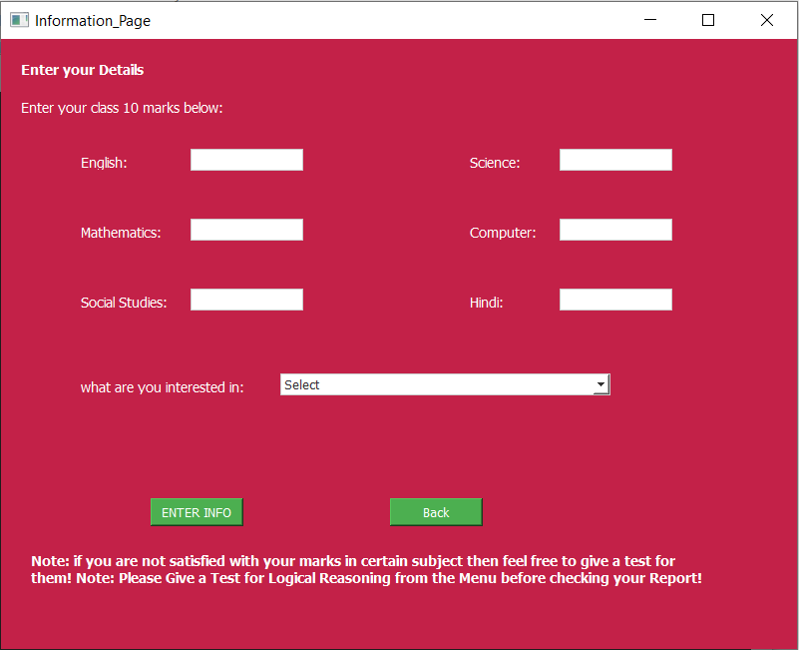

8.5 Output Screenshot 5

**Choose Subject page:**

from PyQt5 import QtCore, QtGui, QtWidgets

import random as rndm

import pandas as pd

import numpy as np

import os

def find_file_path(file_name):

for root, dirs, files in os.walk(os.path.abspath(os.sep)):

if file_name in files:

return os.path.join(root, file_name)

return f"File '{file_name}' not found in the current directory "

class Ui_SubjectWindow(object):

def setupUi(self, SubjectWindow):

education_stylesheet = """

QWidget {

background-color: #C32148;

color: white;

}

QLabel {

font-family: MS Shell Dlg 2;

font-size: 14px;

font-weight: bold;

color: white;

}

QPushButton {

background-color: #4CAF50;

color: white;

}

"""

SubjectWindow.setStyleSheet(education_stylesheet)

self.User_id = ""

SubjectWindow.setObjectName("SubjectWindow")

SubjectWindow.resize(371, 428)

self.centralwidget = QtWidgets.QWidget(SubjectWindow)

self.centralwidget.setObjectName("centralwidget")

self.EnglishButton = QtWidgets.QPushButton(self.centralwidget)

self.EnglishButton.setGeometry(QtCore.QRect(50, 70, 93, 28))

self.EnglishButton.setObjectName("EnglishButton")

self.EnglishButton.clicked.connect(lambda: self.EngTest(SubjectWindow))

self.ScienceButton = QtWidgets.QPushButton(self.centralwidget)

self.ScienceButton.setGeometry(QtCore.QRect(230, 70, 93, 28))

self.ScienceButton.setObjectName("ScienceButton")

self.ScienceButton.clicked.connect(lambda: self.SciTest(SubjectWindow))

self.MathsButton = QtWidgets.QPushButton(self.centralwidget)

self.MathsButton.setGeometry(QtCore.QRect(50, 150, 93, 28))

self.MathsButton.setObjectName("MathsButton")

self.MathsButton.clicked.connect(lambda: self.MathTest(SubjectWindow))

self.LogicalReasoningButton = QtWidgets.QPushButton(self.centralwidget)

self.LogicalReasoningButton.setGeometry(QtCore.QRect(230, 150, 121, 28))

self.LogicalReasoningButton.setObjectName("LogicalReasoningButton")

self.LogicalReasoningButton.clicked.connect(lambda: self.LGTest(SubjectWindow))

self.SSTButton = QtWidgets.QPushButton(self.centralwidget)

self.SSTButton.setGeometry(QtCore.QRect(50, 230, 93, 28))

self.SSTButton.setObjectName("SSTButton")

self.SSTButton.clicked.connect(lambda: self.SStTest(SubjectWindow))

self.ComputerButton = QtWidgets.QPushButton(self.centralwidget)

self.ComputerButton.setGeometry(QtCore.QRect(230, 230, 93, 28))

self.ComputerButton.setObjectName("ComputerButton")

self.ComputerButton.clicked.connect(lambda: self.CompTest(SubjectWindow))

self.label = QtWidgets.QLabel(self.centralwidget)

self.label.setGeometry(QtCore.QRect(40, 10, 301, 21))

font = QtGui.QFont()

font.setPointSize(9)

font.setBold(True)

font.setWeight(75)

self.label.setFont(font)

self.label.setObjectName("label")

self.BackButton = QtWidgets.QPushButton(self.centralwidget)

self.BackButton.setGeometry(QtCore.QRect(140, 310, 93, 28))

self.BackButton.setObjectName("BackButton")

self.BackButton.clicked.connect(lambda: self.Back(SubjectWindow))

SubjectWindow.setCentralWidget(self.centralwidget)

self.menubar = QtWidgets.QMenuBar(SubjectWindow)

self.menubar.setGeometry(QtCore.QRect(0, 0, 371, 26))

self.menubar.setObjectName("menubar")

SubjectWindow.setMenuBar(self.menubar)

self.statusbar = QtWidgets.QStatusBar(SubjectWindow)

self.statusbar.setObjectName("statusbar")

SubjectWindow.setStatusBar(self.statusbar)

self.retranslateUi(SubjectWindow)

QtCore.QMetaObject.connectSlotsByName(SubjectWindow)

def retranslateUi(self, SubjectWindow):

_translate = QtCore.QCoreApplication.translate

SubjectWindow.setWindowTitle(_translate("SubjectWindow", "Choose Subject"))

self.EnglishButton.setText(_translate("SubjectWindow", "English"))

self.ScienceButton.setText(_translate("SubjectWindow", "Science"))

self.MathsButton.setText(_translate("SubjectWindow", "Mathematics"))

self.LogicalReasoningButton.setText(_translate("SubjectWindow", "Logical Reasoning"))

self.SSTButton.setText(_translate("SubjectWindow", "Social Studies"))

self.ComputerButton.setText(_translate("SubjectWindow", "Computer"))

self.label.setText(_translate("SubjectWindow", "Click the Subject you to Take a Test In"))

self.BackButton.setText(_translate("SubjectWindow", "Back"))

def Back(self, SubjectWindow):

from menu_page import Ui_MenuWindow

self.window = QtWidgets.QMainWindow()

self.ui = Ui_MenuWindow()

self.ui.setupUi(self.window)

self.ui.User_id = self.User_id

self.window.show()

SubjectWindow.hide()

def EngTest(self, SubjectWindow):

from take_test_all_other_questions import Ui_TakeTestWindow

data = pd.read_excel(find_file_path('english_questions.xlsx'))

Questions = []

ans=[]

while(len(Questions)!=25):

r = rndm.randint(0,50)

if(r not in Questions):

Questions.append(r)

else:

continue

for i in Questions:

ans.append(data.iloc[i,5])

self.window = QtWidgets.QMainWindow()

self.ui = Ui_TakeTestWindow()

self.ui.setupUi(self.window)

self.ui.User_id = self.User_id

self.ui.English = Questions

self.ui.ans = ans

self.ui.RenderQ(0)

self.window.show()

SubjectWindow.hide()

def MathTest(self, SubjectWindow):

from take_test_all_other_questions import Ui_TakeTestWindow

data = pd.read_excel(find_file_path('Mathematics_questions.xlsx'))

Questions = []

ans=[]

while(len(Questions)!=25):

r = rndm.randint(0,51)

if(r not in Questions):

Questions.append(r)

else:

continue

for i in Questions:

ans.append(data.iloc[i,5])

self.window = QtWidgets.QMainWindow()

self.ui = Ui_TakeTestWindow()

self.ui.setupUi(self.window)

self.ui.User_id = self.User_id

self.ui.Mathematics = Questions

self.ui.ans = ans

self.ui.RenderQ(0)

self.window.show()

SubjectWindow.hide()

def SStTest(self, SubjectWindow):

from take_test_all_other_questions import Ui_TakeTestWindow

data = pd.read_excel(find_file_path('Social_Studies_questions.xlsx'))

Questions = []

ans=[]

while(len(Questions)!=25):

r = rndm.randint(0,49)

if(r not in Questions):

Questions.append(r)

else:

continue

for i in Questions:

ans.append(data.iloc[i,5])

self.window = QtWidgets.QMainWindow()

self.ui = Ui_TakeTestWindow()

self.ui.setupUi(self.window)

self.ui.User_id = self.User_id

self.ui.Social_Studies = Questions

self.ui.ans = ans

self.ui.RenderQ(0)

self.window.show()

SubjectWindow.hide()

def SciTest(self, SubjectWindow):

from take_test_all_other_questions import Ui_TakeTestWindow

data = pd.read_excel(find_file_path('Science_questions.xlsx'))

Questions = []

ans=[]

while(len(Questions)!=25):

r = rndm.randint(0,49)

if(r not in Questions):

Questions.append(r)

else:

continue

for i in Questions:

ans.append(data.iloc[i,5])

self.window = QtWidgets.QMainWindow()

self.ui = Ui_TakeTestWindow()

self.ui.setupUi(self.window)

self.ui.User_id = self.User_id

self.ui.Science = Questions

self.ui.ans = ans

self.ui.RenderQ(0)

self.window.show()

SubjectWindow.hide()

def LGTest(self, SubjectWindow):

from take_test_all_other_questions import Ui_TakeTestWindow

data = pd.read_excel(find_file_path('Logical_Reasoning_questions.xlsx'))

Questions = []

ans=[]

while(len(Questions)!=25):

r = rndm.randint(0,49)

if(r not in Questions):

Questions.append(r)

else:

continue

for i in Questions:

ans.append(data.iloc[i,5])

self.window = QtWidgets.QMainWindow()

self.ui = Ui_TakeTestWindow()

self.ui.setupUi(self.window)

self.ui.User_id = self.User_id

self.ui.Logical_Reasoning = Questions

self.ui.ans = ans

self.ui.RenderQ(0)

self.window.show()

SubjectWindow.hide()

def CompTest(self, SubjectWindow):

from take_test_all_other_questions import Ui_TakeTestWindow

data = pd.read_excel(find_file_path('Computer_questions.xlsx'))

Questions = []

ans=[]

while(len(Questions)!=25):

r = rndm.randint(0,41)

if(r not in Questions):

Questions.append(r)

else:

continue

for i in Questions:

ans.append(data.iloc[i,5])

self.window = QtWidgets.QMainWindow()

self.ui = Ui_TakeTestWindow()

self.ui.setupUi(self.window)

self.ui.User_id = self.User_id

self.ui.Computer = Questions

self.ui.ans = ans

self.ui.RenderQ(0)

self.window.show()

SubjectWindow.hide()

if __name__ == "__main__":

import sys

app = QtWidgets.QApplication(sys.argv)

SubjectWindow = QtWidgets.QMainWindow()

ui = Ui_SubjectWindow()

ui.setupUi(SubjectWindow)

SubjectWindow.show()

sys.exit(app.exec_())

**Output:**

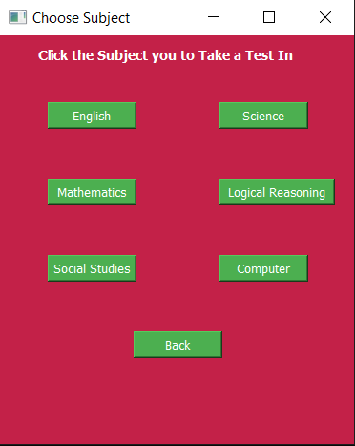

8.6 Output Screenshot 6

**Take Test page:**

from PyQt5 import QtCore, QtGui, QtWidgets

import random as rndm

import pandas as pd

import numpy as np

import sqlite3

import os

def find_file_path(file_name):

for root, dirs, files in os.walk(os.path.abspath(os.sep)):

if file_name in files:

return os.path.join(root, file_name)

return f"File '{file_name}' not found in the current directory "

con = sqlite3.connect(find_file_path('Career_Recommedation_System.db'))

class Ui_TakeTestWindow(object):

def setupUi(self, TakeTestWindow):

education_stylesheet = """

QWidget {

background-color: #C32148;

color: white;

}

QLabel {

font-family: MS Shell Dlg 2;

font-size: 14px;

color: white;

}

QRadioButton {

background-color: #C32148;

color: white;

}

QPushButton {

background-color: #4CAF50;

color: #FFFFFF;

}

QPushButton:hover {

background-color: #6495ED;

}"""

TakeTestWindow.setStyleSheet(education_stylesheet)

self.cur = con.cursor()

self.User_id = ""

self.marks = 0

self.finished = False

self.ans = []

self.selected_answer = ""

self.count = 0

self.English = []

self.Mathematics = []

self.Social_Studies = []

self.Science = []

self.Logical_Reasoning = []

self.Computer = []

font = QtGui.QFont()

font.setFamily("Noto Sans")

font.setPointSize(9)

TakeTestWindow.setObjectName("TakeTestWindow")

TakeTestWindow.resize(800, 600)

self.centralwidget = QtWidgets.QWidget(TakeTestWindow)

self.centralwidget.setObjectName("centralwidget")

self.Option2Button = QtWidgets.QRadioButton(self.centralwidget)

self.Option2Button.setGeometry(QtCore.QRect(40, 230, 731, 31))

self.Option2Button.setObjectName("Option2Button")

self.AnswerbuttonGroup = QtWidgets.QButtonGroup(TakeTestWindow)

self.AnswerbuttonGroup.setObjectName("AnswerbuttonGroup")

self.AnswerbuttonGroup.addButton(self.Option2Button)

self.label_2 = QtWidgets.QLabel(self.centralwidget)

self.label_2.setGeometry(QtCore.QRect(10, 80, 781, 40))

font = QtGui.QFont()

font.setPointSize(9)

self.label_2.setFont(font)

self.label_2.setWordWrap(True)

self.label_2.setObjectName("label_2")

self.Option4Button = QtWidgets.QRadioButton(self.centralwidget)

self.Option4Button.setGeometry(QtCore.QRect(40, 330, 741, 31))

self.Option4Button.setObjectName("Option4Button")

self.AnswerbuttonGroup.addButton(self.Option4Button)

self.Option1Button = QtWidgets.QRadioButton(self.centralwidget)

self.Option1Button.setGeometry(QtCore.QRect(40, 180, 721, 31))

self.Option1Button.setObjectName("Option1Button")

self.AnswerbuttonGroup.addButton(self.Option1Button)

self.label = QtWidgets.QLabel(self.centralwidget)

self.label.setGeometry(QtCore.QRect(20, 20, 151, 31))

font = QtGui.QFont()

font.setPointSize(10)

font.setBold(True)

font.setWeight(75)

self.label.setFont(font)

self.label.setObjectName("label")

self.NextButton = QtWidgets.QPushButton(self.centralwidget)

self.NextButton.setGeometry(QtCore.QRect(620, 460, 93, 28))

self.NextButton.setObjectName("NextButton")

self.NextButton.clicked.connect(lambda: self.nextButtonClicked(TakeTestWindow))

self.Option3Button = QtWidgets.QRadioButton(self.centralwidget)

self.Option3Button.setGeometry(QtCore.QRect(40, 280, 741, 31))

self.Option3Button.setObjectName("Option3Button")

self.AnswerbuttonGroup.addButton(self.Option3Button)

self.BackButton = QtWidgets.QPushButton(self.centralwidget)

self.BackButton.setGeometry(QtCore.QRect(80, 460, 93, 28))

self.BackButton.setObjectName("BackButton")

self.BackButton.clicked.connect(lambda: self.back_button_clicked(TakeTestWindow))

TakeTestWindow.setCentralWidget(self.centralwidget)

self.menubar = QtWidgets.QMenuBar(TakeTestWindow)

self.menubar.setGeometry(QtCore.QRect(0, 0, 800, 26))

self.menubar.setObjectName("menubar")

TakeTestWindow.setMenuBar(self.menubar)

self.statusbar = QtWidgets.QStatusBar(TakeTestWindow)

self.statusbar.setObjectName("statusbar")

TakeTestWindow.setStatusBar(self.statusbar)

self.Option2Button.setFont(font)

self.label_2.setFont(font)

self.Option4Button.setFont(font)

self.Option1Button.setFont(font)

self.label.setFont(font)

self.NextButton.setFont(font)

self.Option3Button.setFont(font)

self.BackButton.setFont(font)

self.retranslateUi(TakeTestWindow)

QtCore.QMetaObject.connectSlotsByName(TakeTestWindow)

def retranslateUi(self, TakeTestWindow):

_translate = QtCore.QCoreApplication.translate

TakeTestWindow.setWindowTitle(_translate("TakeTestWindow", "Test_Page"))

self.Option2Button.setText(_translate("TakeTestWindow", "Option2"))

self.label_2.setText(_translate("TakeTestWindow", "Question"))

self.Option4Button.setText(_translate("TakeTestWindow", "Option4"))

self.Option1Button.setText(_translate("TakeTestWindow", "Option1"))

self.label.setText(_translate("TakeTestWindow", "Question NO. 0"))

self.NextButton.setText(_translate("TakeTestWindow", "Next"))

self.Option3Button.setText(_translate("TakeTestWindow", "Option3"))

self.BackButton.setText(_translate("TakeTestWindow", "Back"))

def back_button_clicked(self, TakeTestWindow):

if self.count > 1:

self.marks -= 4

self.count -= 2

self.RenderQ(self.count)

if self.count == 1:

self.backtomenu(TakeTestWindow)

def backtomenu(self, TakeTestWindow):

from menu_page import Ui_MenuWindow

self.window = QtWidgets.QMainWindow()

self.ui = Ui_MenuWindow()

self.ui.setupUi(self.window)

self.ui.User_id = self.User_id

self.window.show()

TakeTestWindow.hide()

def get_question_data(self, data, subject_list, count):

question = data.iloc[subject_list[count], 0]

a = data.iloc[subject_list[count], 1]

b = data.iloc[subject_list[count], 2]

c = data.iloc[subject_list[count], 3]

d = data.iloc[subject_list[count], 4]

return question, a, b, c, d

def get_selected_answer(self):

if self.Option1Button.isChecked():

return "A"

elif self.Option2Button.isChecked():

return "B"

elif self.Option3Button.isChecked():

return "C"

elif self.Option4Button.isChecked():

return "D"

else:

return ""

def checkAns(self):

if self.selected_answer == self.ans[self.count - 1]:

self.marks += 4

elif self.selected_answer == "":

pass

self.marks = min(self.marks, 100)

def nextButtonClicked(self, TakeTestWindow):

if not self.finished:

self.NextButton.setEnabled(False)

self.selected_answer = self.get_selected_answer()

self.checkAns()

self.RenderQ(self.count)

else:

self.finish(TakeTestWindow)

def RenderQ(self, count):

english_file = find_file_path('english_questions.xlsx')

mathematics_file = find_file_path('Mathematics_questions.xlsx')

social_studies_file = find_file_path('Social_Studies_questions.xlsx')

science_file = find_file_path('Science_questions.xlsx')

logical_reasoning_file = find_file_path('Logical_Reasoning_questions.xlsx')

computer_file = find_file_path('Computer_questions.xlsx')

data = None

question, a, b, c, d = "", "", "", "", ""

if len(self.English) > 0:

data = pd.read_excel(english_file)

question, a, b, c, d = self.get_question_data(data, self.English, count)

elif len(self.Mathematics) > 0:

data = pd.read_excel(mathematics_file)

question, a, b, c, d = self.get_question_data(data, self.Mathematics, count)

elif len(self.Social_Studies) > 0:

data = pd.read_excel(social_studies_file)

question, a, b, c, d = self.get_question_data(data, self.Social_Studies, count)

elif len(self.Science) > 0:

data = pd.read_excel(science_file)

question, a, b, c, d = self.get_question_data(data, self.Science, count)

elif len(self.Logical_Reasoning) > 0:

data = pd.read_excel(logical_reasoning_file)

question, a, b, c, d = self.get_question_data(data, self.Logical_Reasoning, count)

elif len(self.Computer) > 0:

data = pd.read_excel(computer_file)

question, a, b, c, d = self.get_question_data(data, self.Computer, count)

else: self.label_2.setText("error")

if data is not None:

self.count += 1

self.label.setText(f"Question NO. {self.count}")

self.label_2.setText(question)

self.Option1Button.setText(str(a))

self.Option2Button.setText(str(b))

self.Option3Button.setText(str(c))

self.Option4Button.setText(str(d))

else:

self.label_2.setText("error")

self.reset_selection()

self.NextButton.setEnabled(True)

if self.count >= 25:

self.finished = True

self.NextButton.setText("Finish")

def fetchpreviousmarks(self):

if len(self.English) > 0:

try:

statement= f"SELECT English from User_marks WHERE User_id = '{self.User_id}'"

self.cur.execute(statement)

previousmarks = self.cur.fetchone()

con.commit()

except sqlite3.Error as e:

self.label.setText(f"SQLite error: {e}")

elif len(self.Mathematics) > 0:

try:

statement= f"SELECT Mathematics from User_marks WHERE User_id = '{self.User_id}'"

self.cur.execute(statement)

previousmarks = self.cur.fetchone()

con.commit()

except sqlite3.Error as e:

self.label.setText(f"SQLite error: {e}")

elif len(self.Social_Studies) > 0:

try:

statement= f"SELECT Social_Studies from User_marks WHERE User_id = '{self.User_id}'"

self.cur.execute(statement)

previousmarks = self.cur.fetchone()

con.commit()

except sqlite3.Error as e:

self.label.setText(f"SQLite error: {e}")

elif len(self.Science) > 0:

try:

statement= f"SELECT Science from User_marks WHERE User_id = '{self.User_id}'"

self.cur.execute(statement)

previousmarks = self.cur.fetchone()

con.commit()

except sqlite3.Error as e:

self.label.setText(f"SQLite error: {e}")

elif len(self.Logical_Reasoning) > 0:

try:

statement= f"SELECT Logical_Reasoning from User_marks WHERE User_id = '{self.User_id}'"

self.cur.execute(statement)

previousmarks = self.cur.fetchone()

con.commit()

except sqlite3.Error as e:

self.label.setText(f"SQLite error: {e}")

elif len(self.Computer) > 0:

try:

statement= f"SELECT Computer from User_marks WHERE User_id = '{self.User_id}'"

self.cur.execute(statement)

previousmarks = self.cur.fetchone()

con.commit()

except sqlite3.Error as e:

self.label.setText(f"SQLite error: {e}")

else: self.label_2.setText("error")

return previousmarks

def addmarkstodatabase(self):

if len(self.English) > 0:

try:

statement= f"UPDATE User_Marks SET English = {self.marks} WHERE User_id = '{self.User_id}'"

self.cur.execute(statement)

con.commit()

except sqlite3.Error as e:

self.label.setText(f"SQLite error: {e}")

elif len(self.Mathematics) > 0:

try:

statement= f"UPDATE User_Marks SET Mathematics = {self.marks} WHERE User_id = '{self.User_id}'"

self.cur.execute(statement)

con.commit()

except sqlite3.Error as e:

self.label.setText(f"SQLite error: {e}")

elif len(self.Social_Studies) > 0:

try:

statement= f"UPDATE User_Marks SET Social_Studies = {self.marks} WHERE User_id = '{self.User_id}'"

self.cur.execute(statement)

con.commit()

except sqlite3.Error as e:

self.label.setText(f"SQLite error: {e}")

elif len(self.Science) > 0:

try:

statement= f"UPDATE User_Marks SET Science = {self.marks} WHERE User_id = '{self.User_id}'"

self.cur.execute(statement)

con.commit()

except sqlite3.Error as e:

self.label.setText(f"SQLite error: {e}")

elif len(self.Logical_Reasoning) > 0:

try:

statement= f"UPDATE User_Marks SET Logical_Reasoning = {self.marks} WHERE User_id = '{self.User_id}'"

self.cur.execute(statement)

con.commit()

except sqlite3.Error as e:

self.label.setText(f"SQLite error: {e}")

elif len(self.Computer) > 0:

try:

statement= f"UPDATE User_Marks SET Computer = {self.marks} WHERE User_id = '{self.User_id}'"

self.cur.execute(statement)

con.commit()

except sqlite3.Error as e:

self.label.setText(f"SQLite error: {e}")

else: self.label_2.setText("error")

def reset_selection(self):

self.AnswerbuttonGroup.setExclusive(False)

for button in self.AnswerbuttonGroup.buttons():

button.setChecked(False)

self.AnswerbuttonGroup.setExclusive(True)

def finish(self, TakeTestWindow):

from Results import Ui_ResultWindow

result=self.marks

previousmarks = self.fetchpreviousmarks()

previousmarks = int(''.join(map(str,previousmarks)))

if previousmarks < result :

self.addmarkstodatabase()

self.window = QtWidgets.QMainWindow()

self.ui = Ui_ResultWindow()

self.ui.setupUi(self.window)

self.ui.User_id = self.User_id

if len(self.English) > 0:

self.ui.EngMarksLbl.setText(f"{result}")

elif len(self.Mathematics) > 0:

self.ui.MathMarksLbl.setText(f"{result}")

elif len(self.Social_Studies) > 0:

self.ui.SstMarksLbl.setText(f"{result}")

elif len(self.Science) > 0:

self.ui.SciLbl.setText(f"{result}")

elif len(self.Logical_Reasoning) > 0:

self.ui.LgRnLbl.setText(f"{result}")

elif len(self.Computer) > 0:

self.ui.CompLbl.setText(f"{result}")

else: self.label_2.setText("error")

self.window.show()

TakeTestWindow.hide()

if __name__ == "__main__":

import sys

app = QtWidgets.QApplication(sys.argv)

TakeTestWindow = QtWidgets.QMainWindow()

ui = Ui_TakeTestWindow()

ui.setupUi(TakeTestWindow)

TakeTestWindow.show()

sys.exit(app.exec_())

**output:**

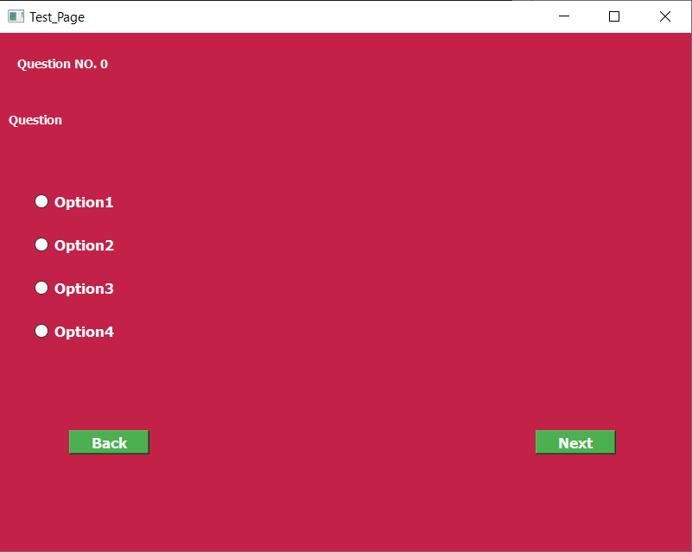

8.7 Output Screenshot 7

**Results page:**

from PyQt5 import QtCore, QtGui, QtWidgets

from menu_page import Ui_MenuWindow

class Ui_ResultWindow(object):

def setupUi(self, ResultWindow):

education_stylesheet = """

QWidget {

background-color: #C32148;

color: white;

}

QLabel {

font-family: MS Shell Dlg 2;

font-size: 18px;

font-weight: bold;

color: white;

}

QPushButton {

background-color: #4CAF50;

color: white;

}

"""

ResultWindow.setStyleSheet(education_stylesheet)

self.User_id = ""

ResultWindow.setObjectName("ResultWindow")

ResultWindow.resize(850, 650)

self.centralwidget = QtWidgets.QWidget(ResultWindow)

self.centralwidget.setObjectName("centralwidget")

self.MenuButton = QtWidgets.QPushButton(self.centralwidget)

self.MenuButton.setGeometry(QtCore.QRect(320, 390, 93, 28))

self.MenuButton.setObjectName("MenuButton")

self.MenuButton.clicked.connect(lambda: self.backtomenu(ResultWindow))

self.label = QtWidgets.QLabel(self.centralwidget)

self.label.setGeometry(QtCore.QRect(90, 100, 100, 21))

self.label.setObjectName("label")

self.EngMarksLbl = QtWidgets.QLabel(self.centralwidget)

self.EngMarksLbl.setGeometry(QtCore.QRect(300, 100, 55, 20))

self.EngMarksLbl.setText("")

self.EngMarksLbl.setObjectName("EngMarksLbl")

self.label_2 = QtWidgets.QLabel(self.centralwidget)

self.label_2.setGeometry(QtCore.QRect(90, 170, 150, 20))

self.label_2.setObjectName("label_2")

self.MathMarksLbl = QtWidgets.QLabel(self.centralwidget)

self.MathMarksLbl.setGeometry(QtCore.QRect(300, 170, 55, 20))

self.MathMarksLbl.setText("")

self.MathMarksLbl.setObjectName("MathMarksLbl")

self.label_3 = QtWidgets.QLabel(self.centralwidget)

self.label_3.setGeometry(QtCore.QRect(90, 240, 150, 20))

self.label_3.setObjectName("label_3")

self.SstMarksLbl = QtWidgets.QLabel(self.centralwidget)

self.SstMarksLbl.setGeometry(QtCore.QRect(300, 240, 55, 20))

self.SstMarksLbl.setText("")

self.SstMarksLbl.setObjectName("SstMarksLbl")

self.label_4 = QtWidgets.QLabel(self.centralwidget)

self.label_4.setGeometry(QtCore.QRect(450, 100, 100, 20))

self.label_4.setFrameShape(QtWidgets.QFrame.NoFrame)

self.label_4.setObjectName("label_4")

self.SciLbl = QtWidgets.QLabel(self.centralwidget)

self.SciLbl.setGeometry(QtCore.QRect(750, 100, 55, 20))

self.SciLbl.setText("")

self.SciLbl.setObjectName("SciLbl")

self.label_5 = QtWidgets.QLabel(self.centralwidget)

self.label_5.setGeometry(QtCore.QRect(450, 170, 250, 20))

self.label_5.setObjectName("label_5")

self.LgRnLbl = QtWidgets.QLabel(self.centralwidget)

self.LgRnLbl.setGeometry(QtCore.QRect(750, 170, 55, 20))

self.LgRnLbl.setText("")

self.LgRnLbl.setObjectName("LgRnLbl")

self.label_7 = QtWidgets.QLabel(self.centralwidget)

self.label_7.setGeometry(QtCore.QRect(450, 240, 120, 20))

self.label_7.setObjectName("label_7")

self.CompLbl = QtWidgets.QLabel(self.centralwidget)

self.CompLbl.setGeometry(QtCore.QRect(750, 240, 55, 20))

self.CompLbl.setText("")

self.CompLbl.setObjectName("CompLbl")

self.label_6 = QtWidgets.QLabel(self.centralwidget)

self.label_6.setGeometry(QtCore.QRect(70, 30, 91, 20))

font = QtGui.QFont()

font.setPointSize(10)

font.setBold(True)

font.setWeight(75)

self.label_6.setFont(font)

self.label_6.setObjectName("label_6")

ResultWindow.setCentralWidget(self.centralwidget)

self.menubar = QtWidgets.QMenuBar(ResultWindow)

self.menubar.setGeometry(QtCore.QRect(0, 0, 800, 26))

self.menubar.setObjectName("menubar")

ResultWindow.setMenuBar(self.menubar)

self.statusbar = QtWidgets.QStatusBar(ResultWindow)

self.statusbar.setObjectName("statusbar")

ResultWindow.setStatusBar(self.statusbar)

self.retranslateUi(ResultWindow)

QtCore.QMetaObject.connectSlotsByName(ResultWindow)

def retranslateUi(self, ResultWindow):

_translate = QtCore.QCoreApplication.translate

ResultWindow.setWindowTitle(_translate("ResultWindow", "Result Page"))

self.MenuButton.setText(_translate("ResultWindow", "Go To Menu"))

self.label.setText(_translate("ResultWindow", "English:"))

self.label_2.setText(_translate("ResultWindow", "Mathematics:"))

self.label_3.setText(_translate("ResultWindow", "Social Studies:"))

self.label_4.setText(_translate("ResultWindow", "Science:"))

self.label_5.setText(_translate("ResultWindow", "Logical Reasoning:"))

self.label_7.setText(_translate("ResultWindow", "Computer:"))

self.label_6.setText(_translate("ResultWindow", "Results:"))

def backtomenu(self, ResultWindow):

self.window = QtWidgets.QMainWindow()

self.ui = Ui_MenuWindow()

self.ui.setupUi(self.window)

self.ui.User_id = self.User_id

self.window.show()

ResultWindow.hide()

if __name__ == "__main__":

import sys

app = QtWidgets.QApplication(sys.argv)

ResultWindow = QtWidgets.QMainWindow()

ui = Ui_ResultWindow()

ui.setupUi(ResultWindow)

ResultWindow.show()

sys.exit(app.exec_())

**output:**

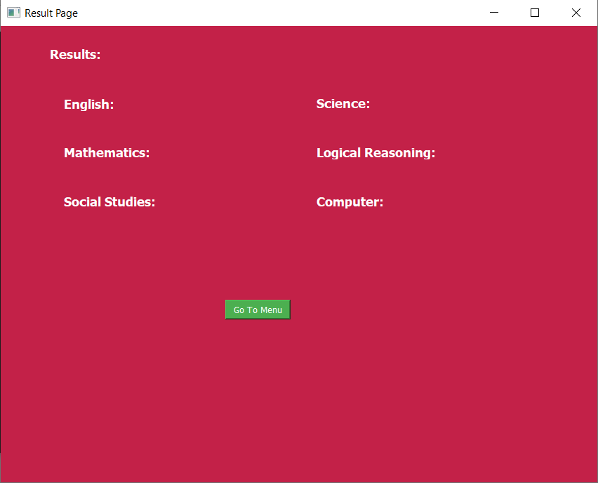

8.8 Output Screenshot 8

**Report page:**

from PyQt5 import QtCore, QtGui, QtWidgets

import pandas as pd

import os

class Ui_ReportWindow(object):

def setupUi(self, ReportWindow):

education_stylesheet = """

QWidget {

background-color: #C32148;

color: white;

}

QLabel {

font-family: MS Shell Dlg 2;

font-size: 18px;

color: white;

}

QLabel#recomjob {

font-family: MS Shell Dlg 2;

font-size: 18px;

color: black;

}

QLabel#WeakLbl {

font-family: MS Shell Dlg 2;

font-size: 18px;

color: black;

}

QLineEdit{

background-color: #FFFFFF;

color: #000000;

border: 1px solid #CCCCCC;

}

QComboBox {

background-color: #FFFFFF;

color: #000000;

border: 1px solid #CCCCCC;

}

QComboBox QAbstractItemView {

background-color: #FFFFFF;

color: #000000;

border: 1px solid #CCCCCC;

}

QComboBox QAbstractItemView::up-arrow, QComboBox QAbstractItemView::down-arrow {

background-color: #FFFFFF;

}

QComboBox QScrollBar:vertical {

background-color: #FFFFFF;

}

QPushButton {

background-color: #4CAF50;

color: white;

}

"""

ReportWindow.setStyleSheet(education_stylesheet)

self.sites={"English":["British Council","Grammarly","BBC Learning English"],

"Mathematics":["NCERT Official Website","Khan Academy","Cuemath"],

"Science":["National Science Digital Library (NSDL)","TopperLearning","Embibe"],

"Social_Studies":["NCERT Official Website","BYJU'S","Meritnation"],

"Logical_Reasoning":["TCY Online","Indiabix","Gradeup"],

"Computer":["Codecademy","Udemy","GeeksforGeeks"]}

self.ITI = {

'ITI in Computer Hardware and Networking': [

'Computer Hardware Technician',

'Network Technician',

'IT Support Technician',

'Field Service Technician',

'System Administrator'

],

'ITI in Information Technology': [

'IT Support Specialist',

'Computer Operator',

'Data Entry Operator',

'IT Assistant',

'Desktop Support Technician'

],

'ITI in Mobile Repair and Maintenance': [

'Mobile Phone Technician',

'Cellphone Repair Technician',

'Mobile Service Technician',

'Mobile Hardware Specialist',

'Cellphone Diagnostic Technician'

],

'ITI in Mechanical': [

'Mechanical Technician',

'Machinist',

'Maintenance Technician',

'Production Assistant',

'Quality Control Technician'

],

'ITI in Automotive Technology': [

'Automotive Technician',

'Automotive Mechanic',

'Auto Repair Technician',

'Automobile Service Technician',

'Automotive Electrician'

],

'ITI in Welding and Fabrication': [

'Welder',

'Fabricator',

'Welding Technician',

'Structural Welder',

'Metal Worker'

],

'ITI in Fitter and Turner': [

'Fitter',

'Turner',

'Assembly Technician',

'Machinist',

'Machine Operator'

],

'ITI in Machinist': [

'Machinist',

'CNC Machinist',

'Tool and Die Maker',

'Machining Technician',

'Lathe Operator'

],

'ITI in Foundry and Pattern Making': [

'Foundry Technician',

'Pattern Maker',

'Metal Casting Technician',

'Foundry Worker',

'Molder'

],

'ITI in CNC Operator': [

'CNC Machine Operator',

'CNC Programmer',

'Machine Shop Operator',

'CNC Technician',

'CNC Machinist'

],

'ITI in Electronics and Communication': [

'Electronics Technician',

'Communication Technician',

'Electronics Assembler',

'PCB Designer',

'Electronics Repair Technician'

],

'ITI in Instrumentation and Control': [

'Instrumentation Technician',

'Control Systems Technician',

'Instrumentation and Control Engineer',

'Calibration Technician',

'Process Control Technician'

],

'ITI in Plumbing and Pipefitting': [

'Plumber',

'Pipefitter',

'Plumbing Technician',

'Pipe Welder',

'Gas Fitter'

],

'ITI in Carpentry and Woodworking': [

'Carpenter',

'Woodworker',

'Cabinet Maker',

'Furniture Designer',

'Joinery Technician'

],

'ITI in Beauty and Wellness': [

'Beautician',

'Hair Stylist',

'Makeup Artist',

'Spa Therapist',

'Skin Care Specialist'

]

}

self.Diploma = {

'Diploma in Computer Science': [

'Software Developer',

'Network Administrator',

'Database Administrator',

'Web Developer',

'Systems Analyst',

'IT Support Specialist',

'Cybersecurity Analyst'

],

'Diploma in Digital Marketing': [

'Digital Marketing Specialist',

'Social Media Manager',

'SEO Specialist',

'Content Marketing Manager',

'Email Marketing Specialist',

'PPC Specialist'

],

'Diploma in Mobile App Development': [

'Mobile App Developer',

'App Tester',

'App Designer',

'UI/UX Designer',

'Mobile App Support Technician'

],

'Diploma in Cybersecurity': [

'Cybersecurity Analyst',

'Security Consultant',

'Incident Responder',

'Security Engineer',

'Penetration Tester'

],

'Diploma in Web Development': [

'Web Developer',

'Front-End Developer',

'Back-End Developer',

'UI/UX Designer',

'Web Content Manager'

],

'Diploma in Mechanical Engineering': [

'Mechanical Engineer',

'Maintenance Technician',

'CAD Technician',

'Quality Control Technician',

'Production Supervisor'

],

'Diploma in Civil Engineering': [

'Civil Engineer',

'Construction Supervisor',

'Surveyor',

'CAD Technician',

'Site Engineer'

],

'Diploma in Electrical Engineering': [

'Electrical Engineer',

'Electrician',

'Electrical Technician',

'Control Panel Designer',

'Power Plant Technician'

],

'Diploma in Automobile Engineering': [

'Automotive Engineer',

'Automotive Technician',

'Service Advisor',

'Quality Control Engineer',

'Automotive Designer'

],

'Diploma in Chemical Engineering': [

'Chemical Engineer',

'Process Technician',

'Quality Control Technician',

'Laboratory Technician',

'Production Supervisor'

],

'Diploma in Electronics and Communication': [

'Electronics Technician',

'Telecommunication Technician',

'Electronic Equipment Assembler',

'Broadcast Technician',

'Electronics Engineer'

],

'Diploma in Architecture': [

'Architectural Drafter',

'Architectural Assistant',

'Building Inspector',

'CAD Technician',

'Construction Supervisor'

],

'Diploma in Interior Design': [

'Interior Designer',

'Interior Decorator',

'Furniture Designer',

'Retail Store Designer',

'Set Designer'

],

'Diploma in Hotel Management': [

'Hotel Manager',

'Front Office Executive',

'Food and Beverage Manager',

'Restaurant Manager',

'Guest Relations Manager'

],

'Diploma in Event Management': [

'Event Planner',

'Event Coordinator',

'Wedding Planner',

'Conference Manager',

'Exhibition Organizer'

],

'Diploma in Aviation and Hospitality Management': [

'Airport Ground Staff',

'Cabin Crew',

'Airport Operations Manager',

'Airline Customer Service Agent',

'Hotel Front Desk Officer'

],

'Diploma in Biotechnology': [

'Laboratory Technician',

'Biotechnician',

'Research Assistant',

'Quality Control Analyst',

'Bioprocess Operator'

],

'Diploma in Environmental Science': [

'Environmental Technician',

'Environmental Consultant',

'Sustainability Specialist',

'Water Quality Analyst',

'Ecosystem Manager'

],

'Diploma in Veterinary Science': [

'Veterinary Assistant',

'Animal Health Technician',

'Veterinary Technician',

'Pet Groomer',

'Wildlife Rehabilitator'

],

'Diploma in Animation and Multimedia': [

'Animator',

'Graphic Designer',

'Video Editor',

'Multimedia Artist',

'Motion Graphics Designer'

],

'Diploma in Film Making and Direction': [

'Film Director',

'Screenwriter',

'Film Producer',

'Cinematographer',

'Film Editor'

],

'Diploma in Photography': [

'Photographer',

'Photojournalist',

'Photo Editor',

'Studio Manager',

'Photography Instructor'

],

'Diploma in Early Childhood Education': [

'Preschool Teacher',

'Childcare Worker',

'Early Childhood Educator',

'Curriculum Developer',

'Child Development Specialist'

],

'Diploma in Yoga and Wellness': [

'Yoga Instructor',

'Wellness Coach',

'Holistic Health Practitioner',

'Fitness Trainer',

'Meditation Instructor'

],

'Diploma in Financial Accounting': [

'Accounts Assistant',

'Junior Accountant',

'Bookkeeper',

'Tax Assistant',

'Audit Assistant'

]

}

self.Vocational = {

'Vocational Training in Data Entry and Office Automation': [

'Data Entry Operator',

'Office Assistant',

'Administrative Assistant'

],

'Vocational Training in Computer Programming': [

'Junior Programmer',

'Software Developer',

'Web Developer',

'Application Developer'

],

'Vocational Training in Mobile App Development': [

'Mobile App Developer',

'App Tester',

'App Designer',

'UI/UX Designer',

'Mobile App Support Technician'

],

'Vocational Training in Web Development': [

'Web Developer',

'Front-End Developer',

'Back-End Developer',

'UI/UX Designer',

'Web Content Manager'

],

'Vocational Training in Computer Hardware and Networking': [

'IT Support Technician',

'Network Technician',

'Hardware Technician',

'System Administrator',

'Network Administrator'

],

'Vocational Training in Mobile Phone Repair Technician': [

'Mobile Phone Technician',

'Cellphone Repair Technician',

'Mobile Service Technician',

'Mobile Hardware Specialist'

],

'Vocational Training in Welding Technician': [

'Welder',

'Fabricator',

'Welding Technician'

],

'Vocational Training in Automotive Technician': [

'Automotive Technician',

'Automotive Mechanic',

'Auto Repair Technician',

'Automobile Service Technician',

'Automotive Electrician'

],

'Vocational Training in Electrician': [

'Electrician',

'Electrical Technician',

'Control Panel Designer',

'Power Plant Technician'

],

'Vocational Training in AutoCAD and Drafting Certification': [

'CAD Technician',

'Draftsman',

'Design Engineer'

],

'Vocational Training in Robotics and Automation Workshop': [

'Robotics Technician',

'Automation Technician',

'Robotics Programmer'

],

'Vocational Training in Machinist and CNC Operator': [

'Machinist',

'CNC Machine Operator',

'Machine Shop Operator'

],

'Vocational Training in HVAC Technician': [

'HVAC Technician',

'Heating and Cooling Technician'

],

'Vocational Training in Plumbing and Pipefitting': [

'Plumber',

'Pipefitter',

'Pipe Welder',

'Gas Fitter'

],

'Vocational Training in Carpentry and Woodworking': [

'Carpenter',

'Woodworker',

'Cabinet Maker',

'Furniture Designer'

],

'Vocational Training in Hospitality and Customer Service': [

'Hotel Front Desk Officer',

'Guest Service Agent',

'Customer Service Representative'

],

'Vocational Training in Healthcare Assistant Training': [

'Healthcare Assistant',

'Nursing Assistant'

],

'Vocational Training in Basic First Aid and Safety Training': [

'First Aid Responder',

'Safety Officer'

],

'Vocational Training in Retail Sales and Customer Service': [

'Retail Sales Associate',

'Customer Service Representative'

],

'Vocational Training in Graphic Design Essentials': [

'Graphic Designer',

'Visual Designer'

],

'Vocational Training in Digital Marketing Certification': [

'Digital Marketing Specialist',

'Social Media Manager',

'SEO Specialist'

],

'Vocational Training in Photography and Videography Course': [

'Photographer',

'Videographer',

'Photo Editor'

],

'Vocational Training in Fashion Design and Tailoring': [

'Fashion Designer',

'Tailor',

'Clothing Designer'

],

'Vocational Training in Language Proficiency Course': [

'Translator',

'Language Instructor'

],

'Vocational Training in Beauty and Makeup Artistry': [

'Makeup Artist',

'Beauty Consultant'

],

'Vocational Training in Entrepreneurship and Business Skills': [

'Entrepreneur',

'Small Business Owner',

'Business Consultant'

],

'Vocational Training in Culinary Arts and Cooking': [

'Cook',

'Chef',

'Sous Chef'

],

'Vocational Training in Baking and Pastry Arts': [

'Baker',

'Pastry Chef'

],

'Vocational Training in Food Safety and Hygiene Certification': [

'Food Safety Inspector',

'Food Safety Coordinator'

]

}

self.Branch = 0

self.User_id = ""

self.temp = ""

self.weaksubs = []

ReportWindow.setObjectName("ReportWindow")

ReportWindow.resize(1000, 550)

self.centralwidget = QtWidgets.QWidget(ReportWindow)

self.centralwidget.setObjectName("centralwidget")

self.label = QtWidgets.QLabel(self.centralwidget)

self.label.setGeometry(QtCore.QRect(30, 10, 161, 41))

font = QtGui.QFont()

font.setPointSize(12)

font.setBold(True)

font.setWeight(75)

self.label.setFont(font)

self.label.setObjectName("label")

self.StrtMsgLbl = QtWidgets.QLabel(self.centralwidget)

self.StrtMsgLbl.setGeometry(QtCore.QRect(30, 60, 351, 31))

self.StrtMsgLbl.setObjectName("StrtMsgLbl")

self.label_2 = QtWidgets.QLabel(self.centralwidget)

self.label_2.setGeometry(QtCore.QRect(20, 200, 500, 16))

font = QtGui.QFont()

font.setBold(True)

font.setWeight(75)

self.label_2.setFont(font)

self.label_2.setObjectName("label_2")

self.recomjob = QtWidgets.QLabel(self.centralwidget)

self.recomjob.setGeometry(QtCore.QRect(570, 280, 311, 191))

self.recomjob.setStyleSheet("background-color: rgb(255, 255, 255);")

self.recomjob.setObjectName("recomjob")

self.label_5 = QtWidgets.QLabel(self.centralwidget)

self.label_5.setGeometry(QtCore.QRect(490, 290, 55, 16))

font = QtGui.QFont()

font.setBold(True)

font.setWeight(75)

self.label_5.setFont(font)

self.label_5.setObjectName("label_5")

self.RecomCB = QtWidgets.QComboBox(self.centralwidget)

self.RecomCB.setGeometry(QtCore.QRect(550, 200, 331, 22))

self.RecomCB.setObjectName("RecomCB")

self.RecomCB.addItem("")

self.RecomCB.addItem("")

self.RecomCB.addItem("")

self.RecomCB.addItem("")

self.RecomCB.addItem("")

self.RecomCB.addItem("")

self.RecomCB.addItem("")

self.RecomCB.addItem("")

self.RecomCB.addItem("")

self.RecomCB.addItem("")

self.RecomCB.addItem("")

self.RecomCB.currentIndexChanged.connect(self.genjobs)

self.label_3 = QtWidgets.QLabel(self.centralwidget)

self.label_3.setGeometry(QtCore.QRect(20, 290, 211, 16))

font = QtGui.QFont()

font.setBold(True)

font.setWeight(75)

self.label_3.setFont(font)

self.label_3.setObjectName("label_3")

self.BackButton = QtWidgets.QPushButton(self.centralwidget)

self.BackButton.setGeometry(QtCore.QRect(360, 440, 93, 28))

self.BackButton.setObjectName("BackButton")

self.BackButton.clicked.connect(lambda: self.backtomenu(ReportWindow))

self.RecomendLbl = QtWidgets.QLabel(self.centralwidget)

self.RecomendLbl.setGeometry(QtCore.QRect(20, 120, 900, 20))

font = QtGui.QFont()

font.setBold(True)

font.setWeight(75)

self.RecomendLbl.setFont(font)

self.RecomendLbl.setObjectName("RecomendLbl")

self.WeakButton = QtWidgets.QPushButton(self.centralwidget)

self.WeakButton.setGeometry(QtCore.QRect(180, 430, 93, 28))

self.WeakButton.setObjectName("WeakButton")

self.WeakButton.clicked.connect(lambda: self.Tips_page(ReportWindow))

self.WeakLbl = QtWidgets.QLabel(self.centralwidget)

self.WeakLbl.setGeometry(QtCore.QRect(260, 290, 171, 101))

self.WeakLbl.setStyleSheet("background-color: rgb(255, 255, 255);")

self.WeakLbl.setObjectName("WeakLbl")

self.label_4 = QtWidgets.QLabel(self.centralwidget)

self.label_4.setGeometry(QtCore.QRect(10, 440, 160, 16))

font = QtGui.QFont()

font.setBold(True)

font.setWeight(75)

self.label_4.setFont(font)

self.label_4.setObjectName("label_4")

ReportWindow.setCentralWidget(self.centralwidget)

self.menubar = QtWidgets.QMenuBar(ReportWindow)

self.menubar.setGeometry(QtCore.QRect(0, 0, 912, 26))

self.menubar.setObjectName("menubar")

ReportWindow.setMenuBar(self.menubar)

self.statusbar = QtWidgets.QStatusBar(ReportWindow)

self.statusbar.setObjectName("statusbar")

ReportWindow.setStatusBar(self.statusbar)

self.retranslateUi(ReportWindow)

QtCore.QMetaObject.connectSlotsByName(ReportWindow)

def retranslateUi(self, ReportWindow):

_translate = QtCore.QCoreApplication.translate

ReportWindow.setWindowTitle(_translate("ReportWindow", "Career Report"))

self.label.setText(_translate("ReportWindow", "Career Report"))

self.RecomCB.setItemText(0,"Select Your Course")

self.StrtMsgLbl.setText(_translate("ReportWindow", "Dear, "))

self.label_2.setText(_translate("ReportWindow", "We recommend that you do the following Courses:"))

self.recomjob.setText(_translate("ReportWindow", "Job List"))

self.label_5.setText(_translate("ReportWindow", "Jobs:"))

self.label_3.setText(_translate("ReportWindow", "Look at your weakness:"))

self.BackButton.setText(_translate("ReportWindow", "Back To Menu"))

self.RecomendLbl.setText(_translate("ReportWindow", "You have been recommended, "))

self.WeakButton.setText(_translate("ReportWindow", "Go!"))

self.WeakLbl.setText(_translate("ReportWindow", "TextLabel"))

self.label_4.setText(_translate("ReportWindow", "For tips look here:"))

def genjobs(self):

select = self.RecomCB.currentText()

recommended_jobs = ""

if self.Branch == 0:

for j in self.Diploma.keys():

if j == select:

recommended_jobs = "\n".join(self.Diploma[j])

elif self.Branch == 1:

for j in self.ITI.keys():

if j == select:

recommended_jobs = "\n".join(self.ITI[j])

elif self.Branch == 2:

for j in self.Vocational.keys():

if j == select:

recommended_jobs = "\n".join(self.Vocational[j])

self.recomjob.setText(recommended_jobs)

def backtomenu(self, ReportWindow):

from menu_page import Ui_MenuWindow

self.window = QtWidgets.QMainWindow()

self.ui = Ui_MenuWindow()

self.ui.setupUi(self.window)

self.ui.User_id = self.User_id

self.window.show()

ReportWindow.hide()

def find_file_path(self,file_name):

for root, dirs, files in os.walk(os.path.abspath(os.sep)):

if file_name in files:

return os.path.join(root, file_name)

return f"File '{file_name}' not found"

def GenTipsandwebsites(self):

tips = pd.read_excel(self.find_file_path("Tips_all_subjects.xlsx"))

tips.set_index('subject',inplace = True)

for i in self.weaksubs:

self.temp += f"Tips for {i}\n"

self.temp += "\n"

for j in tips.loc[i].values:

self.temp += f"{j}\n"

self.temp += "\n"

self.temp +=f"Websites that will be helpful in your studies:\n"

self.temp += "\n"

for j in self.sites[i]:

self.temp += f"{j}\n"

self.temp += "\n"

def Tips_page(self, ReportWindow):

from Guide_page import Ui_GuideWindow

self.window = QtWidgets.QMainWindow()

self.ui = Ui_GuideWindow()

self.ui.setupUi(self.window)

self.GenTipsandwebsites()

self.ui.label.setText(self.temp)

self.ui.User_id = self.User_id

self.window.show()

ReportWindow.hide()

if __name__ == "__main__":

import sys

app = QtWidgets.QApplication(sys.argv)

ReportWindow = QtWidgets.QMainWindow()

ui = Ui_ReportWindow()

ui.setupUi(ReportWindow)

ReportWindow.show()

sys.exit(app.exec_())

**output:**

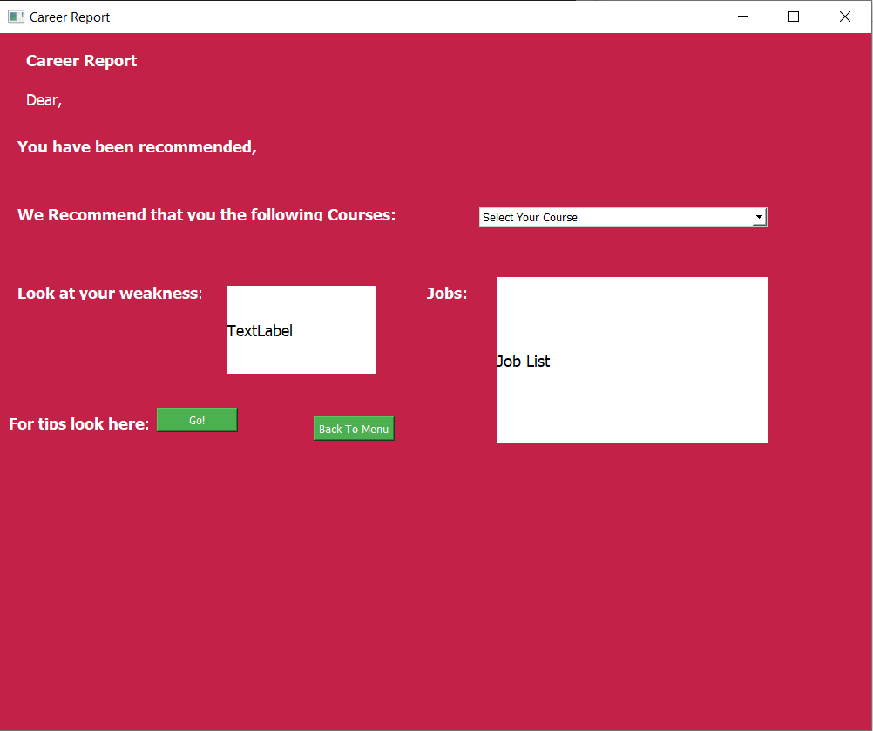

8.9 Output Screenshot 9\

**Tips Page:**

from PyQt5 import QtCore, QtGui, QtWidgets

class Ui_GuideWindow(object):

def setupUi(self, GuideWindow):

education_stylesheet = """

QWidget {

background-color: #C32148;

color: white;

}

QLabel {

font-family: MS Shell Dlg 2;

font-size: 14px;

font-weight: bold;

color: black;

line-height: 1.6;

alignment: AlignTop;

}

QPushButton {

background-color: #4CAF50;

color: white;

}

"""

GuideWindow.setStyleSheet(education_stylesheet)

self.User_id = ""

GuideWindow.setObjectName("GuideWindow")

GuideWindow.resize(795, 629)

self.centralwidget = QtWidgets.QWidget(GuideWindow)

self.centralwidget.setObjectName("centralwidget")

self.label = QtWidgets.QLabel(self.centralwidget)

self.label.setGeometry(QtCore.QRect(20, 20, 751, 511))

self.label.setStyleSheet("background-color: rgb(255, 255, 255);")

self.label.setWordWrap(True)

self.label.setObjectName("label")

self.label.setAlignment(QtCore.Qt.AlignTop)

self.BackButton = QtWidgets.QPushButton(self.centralwidget)

self.BackButton.setGeometry(QtCore.QRect(18, 540, 93, 28))

self.BackButton.setObjectName("BackButton")

self.BackButton.clicked.connect(lambda: self.backtomenu(GuideWindow))

GuideWindow.setCentralWidget(self.centralwidget)

self.menubar = QtWidgets.QMenuBar(GuideWindow)

self.menubar.setGeometry(QtCore.QRect(0, 0, 795, 26))

self.menubar.setObjectName("menubar")

GuideWindow.setMenuBar(self.menubar)

self.statusbar = QtWidgets.QStatusBar(GuideWindow)

self.statusbar.setObjectName("statusbar")

GuideWindow.setStatusBar(self.statusbar)

self.retranslateUi(GuideWindow)

QtCore.QMetaObject.connectSlotsByName(GuideWindow)

def retranslateUi(self, GuideWindow):

_translate = QtCore.QCoreApplication.translate

GuideWindow.setWindowTitle(_translate("GuideWindow", "Tips_Page"))

self.label.setText(_translate("GuideWindow", "TextLabel"))

self.BackButton.setText(_translate("GuideWindow", "Back to Menu"))

def backtomenu(self, GuideWindow):

from menu_page import Ui_MenuWindow

self.window = QtWidgets.QMainWindow()

self.ui = Ui_MenuWindow()

self.ui.setupUi(self.window)

self.ui.User_id = self.User_id

self.window.show()

GuideWindow.hide()

if __name__ == "__main__":

import sys

app = QtWidgets.QApplication(sys.argv)

GuideWindow = QtWidgets.QMainWindow()

ui = Ui_GuideWindow()

ui.setupUi(GuideWindow)

GuideWindow.show()

sys.exit(app.exec_())

**output:**

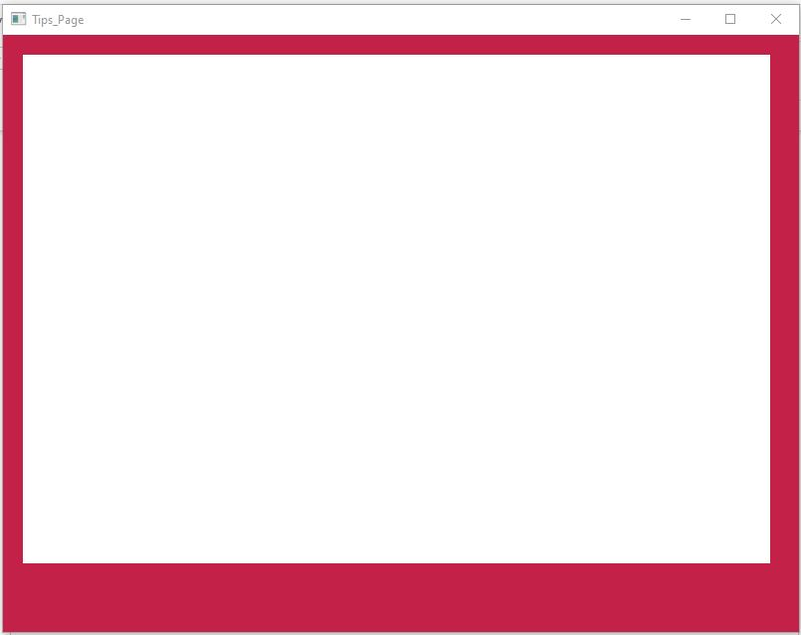

8.10 Output Screenshot 10

**Chapter 9: Conclusion and Future Scope**

The career recommendation system is a desktop application which based on machine learning. This application assists students in choosing their career path after completing secondary education. The main objective of this model is to help students make career decision will lead to professional success. The python random function is used to generate the data that contains the marks of students and courses which forms the basis of the model. This model is based on classification algorithm i.e., KNN which predicts the best field according to their marks of the student in different subjects.

Python-based Qt Designer is used to construct the user interface that will allow users to interact with this application. The drag and drop functionality of this software application makes creating user interfaces easy and fast. Users have two options for creating their career report, which includes recommendations for the best courses, either based on their marks or by taking a test with multiple choice questions covering different areas. Additionally, the user is able to identify their areas of weakness so they can fix them and get the best possible courses.

In the future, the development of our career recommendation system offers promising opportunities for advancement. Furthermore, exploring alternative machine learning algorithms beyond K-Nearest Neighbors (KNN) promises to improve accuracy. The user interface is also a crucial focal point for future development. Evolving the interface to accommodate mobile devices and ensuring adaptability across platforms can enhance accessibility. Integrating intuitive data visualizations and personalization features within the interface aims to provide a more engaging and informative experience for students, aiding in better comprehension of their career suggestions.

**Chapter 10: References**

**Geeks For Geeks**

**Javatpoint**

**Github:** https://github.com/sanikass/Careerly-An-Intelligent-Career-Guidance-System

**Tutorialspoint  
LearnEnough**

**Numpy Documentation**

**India Today:** https://worlduniversityofdesign.nopaperforms.com/